|  |  |
| --- | --- |
| Logo AGES | |
| Stripe smut of rye | |
|  |  |
| 30.04.2025 12:43 Uhr | |

**Stripe
smut
of
rye**

**Urocystis
occulta**

Last
change:
10.04.2025

**Profile**

Rye
stem
blight
is
caused
by
a
fungus
and
mainly
affects
winter
rye
and
winter
triticale.
The
main
characteristic
of
this
pathogen
is
long
spore
deposits
on
leaves
and
stalks
in
conjunction
with
a
clear
reduction
in
the
growth
of
the
host
plant.

**Damage
symptoms**

Long,
1-1.5
mm
wide,
lead-gray
spore
deposits
on
leaves
and
culms
are
typical
of
rye
stem
blight.
These
may
later
rupture.
The
affected
host
plants
are
usually
distinctly
shortened
and
deformed.

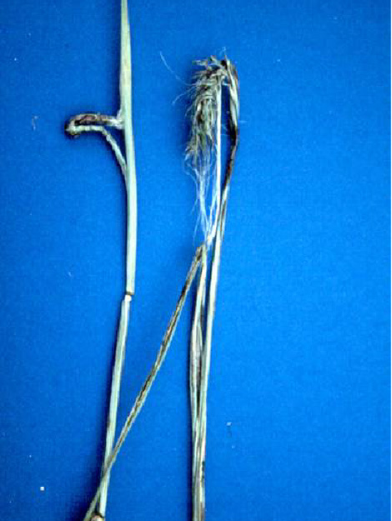

Symptome
des
Roggenstängelbrands
an
Roggen

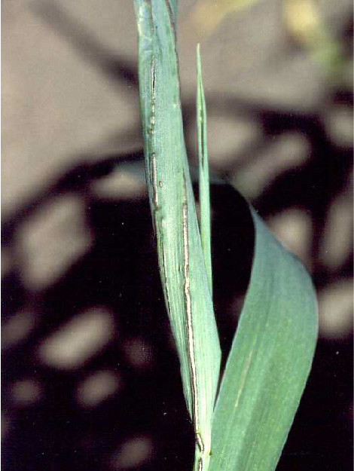

Sporenlager

**Host
plants**

The
main
host
plants
of
rye
stem
blight
are
winter
rye
and
winter
triticale
(a
cross
between
wheat
and
rye).

**Distribution**

The
rye
stalk
fire
can
be
found
in
all
cultivation
areas.

**Propagation
and
transmission**

A
spread
of
the
spores
into
uncontaminated
soils
takes
place
by
means
of
infected
seeds.
The
outbreak
of
the
diseases
leaves
burn
spores
in
the
soil,
which
in
turn
can
infect
a
new
generation
of
seedlings.

**Economic
importance**

In
case
of
severe
infestation
with
rye
stem
blight,
high
yield
losses
and
limited
usability
of
the
crop
(also
for
feed
purposes)
are
to
be
expected.

**Prevention
and
control**

* Use
  of
  tested
  and
  healthy
  seeds
  is
  recommended
* Adherence
  to
  a
  wide
  rye
  crop
  rotation
  on
  contaminated
  soils
* If
  necessary,
  seed
  dressing
  is
  possible

**Services**

[Plant
Health
Services](en/plant/plant-health/plant-health-information)