|  |  |
| --- | --- |
| Logo AGES | |
| Stripe rust | |
|  |  |
| 09.05.2025 19:01 Uhr | |

**Stripe
rust**

**Puccinia
striiformis**

Last
change:
22.11.2021

**Profile**

Cereal
yellow
rust,
or
stripe
rust,
is
a
fungal
disease
that
occurs
mainly
after
mild
winters
and
cool,
damp
weather
in
spring.
Infestation
is
recognizable
by
the
yellow
pustules
arranged
in
stripes,
which
are
formed
along
infested
leaves.

**Biology**

Yellow
rust
belongs
to
the
stand
fungi
(Basidiomycota)
and
is
an
obligate
parasite.
This
means
that
it
requires
surviving
host
plants
throughout
the
year
in
order
to
survive.
It
has
an
incomplete
development
cycle
because
it
does
not
produce
all
spore
forms.
When
an
infestation
occurs,
so-called
running
hyphae
are
formed
inside
the
leaf
along
the
leaf
veins
for
rapid
dispersal
and
numerous
spore
deposits
are
formed,
which
appear
as
rust
spore
pustules
arranged
in
stripes.
This
is
why
yellow
rust
has
also
been
given
the
name
stripe
rust.

**Damage
symptoms**

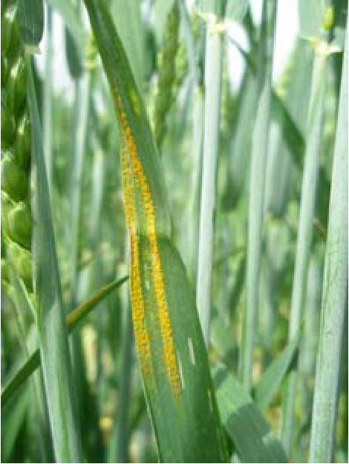

Gelbrost
in
Form
gelber
Sporenstreifen
entlang
eines
befallenen
Blattes

At
first,
bright
yellow
rust
pustules
can
be
seen
scattered
irregularly
on
the
leaves,
which
develop
into
numerous
strip-shaped
pustules
between
the
leaf
veins
as
the
disease
progresses.
The
glumes,
awns
and
culms
are
also
affected,
and
rarely
the
leaf
sheaths.
In
very
heavily
infested
and
highly
susceptible
varieties,
the
rust
pustules
arranged
in
stripes
merge
together
and
cover
larger
areas
on
the
leaves.
This
eventually
leads
to
emergency
ripening
of
the
plants.
In
the
early
stages,
yellow
rust
occurs
in
a
nest-like
manner
in
a
stand,
from
where
it
then
spreads.
Before
the
plants
mature,
brown-black
spore
deposits
are
formed
on
the
undersides
of
the
leaves.
These
spore
deposits
remain
covered
by
the
epidermis
for
a
very
long
time.
Some
varieties
also
react
to
infestation
with
atypical
chlorotic
brightening.

**Host
plants**

Yellow
rust
mainly
attacks
winter
wheat,
winter
triticale,
winter
durum
and
spelt,
as
well
as
barley.
Rye
is
much
less
affected
and
to
a
lesser
extent.
Yellow
rust
can
also
occur
on
numerous
grass
species.

**Distribution**

Yellow
rust
prefers
cool,
humid
climates
in
northwestern
Europe,
but
also
occurs
in
wetter
and
higher-altitude
cereal-growing
areas.
If
susceptible
varieties
are
grown
in
dry
areas,
however,
it
can
also
cause
yield
losses
there.

**Propagation
and
transmission**

Yellow
rust
survives
the
winter
on
volunteer
and
winter
cereals
by
means
of
spores
(uredospores)
and/or
as
mycelium.
In
frost
the
spores
die,
in
severe
winters
also
the
fungal
mycelium.

A
special
feature
of
yellow
rust
is
that
the
uredospores
are
embedded
in
thin
mucilage
substances
in
their
spore
stores.
In
spring,
therefore,
wind
and
rain
increasingly
transport
spore
packages
rather
than
individual
spores.
If
a
spore
gets
onto
a
host
plant,
liquid
water
must
be
present
for
it
to
germinate.
Infections
can
occur
as
early
as
0
°C.
The
fungal
spores
germinate
in
a
film
of
water
in
darkness
and
penetrate
their
host
plants
through
stomata.
Even
relatively
few
spores
are
sufficient
to
cause
severe
infections.
The
risk
of
an
epidemic
is
greatest
at
10
to
15
°C,
high
humidity
and
high
light
intensity.
However,
a
yellow
rust
epidemic
can
also
continue
to
develop
during
very
warm
to
hot
weather
periods.
However,
for
this
to
happen,
dew
must
form
at
night
and
temperatures
must
fall
below
15
°C.

The
best
conditions
for
the
risk
of
a
yellow
rust
epidemic
are:
Failure
cereals
become
infected
in
the
fall,
early
sowing
of
winter
cereals,
mild
winters
or
a
protective
snow
cover,
damp-cool
weather
in
the
spring,
cultivation
of
susceptible
varieties,
and
a
high
nitrogen
supply
to
the
soil.

**Economic
importance**

Yield
losses
of
up
to
50%
are
possible.
Economically,
yellow
rust
is
mainly
of
importance
in
wheat.

**Prevention
and
control**

* Preventive
  careful
  removal
  of
  volunteer
  cereals.
* Avoid
  cultivation
  of
  winter
  crops
  too
  early
* As
  far
  as
  possible,
  spatial
  separation
  of
  fall
  and
  spring
  sowings
  of
  the
  same
  cereal
  variety
* Cultivation
  of
  less
  susceptible
  varieties
* Possibly
  also
  use
  of
  plant
  protection
  products
  (see
  [list
  of
  plant
  protection
  products
  approved
  in
  Austria](https://www.baes.gv.at/zulassung/pflanzenschutzmittel/pflanzenschutzmittelregister/))

**Specialized
information**

Yellow
rust
epidemics
occur
when
a
new
breed
appears
in
the
already
complex
breed
mixture,
either
through
mutation
or
sexual
recombination.
In
Austria,
this
was
the
case
from
1998
to
2001
and
has
also
been
observed
since
2013.
For
this
reason,
varietal
resistance
also
does
not
remain
stable
in
some
cases.
Therefore,
regular
monitoring
of
the
stocks
is
recommended
even
for
varieties
described
as
more
resistant.
When
new
races
appear,
they
are
included
in
the
race
mixture
for
the
tests
of
specific
variety
resistance
in
the
following
year.

**Services**

[Plant
Health
Services](en/plant/plant-health/plant-health-information)