|  |  |
| --- | --- |
| Logo AGES | |
| Phytophthora cactorum on strawberry | |
|  |  |
| 09.05.2025 14:35 Uhr | |

**Phytophthora
cactorum
on
strawberry**

**Phytophthora
cactorum**

Last
change:
05.09.2024

**Profile**

Rhizome
rot
is
caused
by
an
egg
fungus*(P.
cactorum*).
It
attacks
a
large
number
of
different
plants,
including
strawberries.
Infestation
can
be
recognized
by
the
brown
to
reddish-brown
rot
spots,
which
are
usually
sharply
defined.

**Biology**

Infections
occur
from
the
soil,
from
where
the
pathogens
colonize
the
rhizomes
and
roots
or
reach
the
fruit
via
rain
splash.
Due
to
lower
temperatures,
*P.
cactorum*
activity
decreases
again
in
October
and
November.

As
infected
plants
die,
the
pathogens
re-enter
the
soil.
There,
*P.
cactorum*
forms
permanent
organs
that
are
highly
resistant
to
weather
conditions
or
tillage
and
can
persist
in
the
soil
for
many
years.
If
a
host
plant
is
cultivated,
the
pathogens
can
cause
new
infections.

**Damage
symptoms**

At
the
beginning
of
rhizome
rot
heart
leaves
of
the
plants
wither,
then
often
turn
blue-green
and
then
turn
brown.
Death
of
the
plants
occurs
within
a
few
days.

If
the
rhizomes
are
cut
open,
reddish-brown
discoloration
can
be
seen
with
clear
demarcation
from
healthy
tissue.
The
roots
are
asymptomatic
at
the
beginning
of
the
disease
and
die
as
the
disease
progresses.
When
diseased
plants
are
lifted,
they
often
snap
off
at
the
top
of
the
crown.

Immature,
infected
fruits
are
brown
and
have
a
leathery
consistency.
If
infection
occurs
just
before
harvest,
berries
have
a
pale
color
and
browned
vascular
bundles.
Diseased
strawberries
taste
bitter.

Symptoms
often
appear
either
about
four
weeks
after
planting
or
in
the
spring
after
flowering.
Frigo
plants
are
more
sensitive
to
the
disease
than
green
plants.

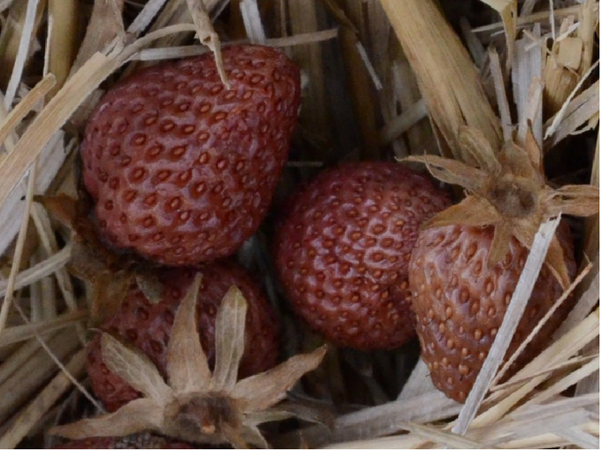

Fruchtsymptome
der
Rhizomfäule

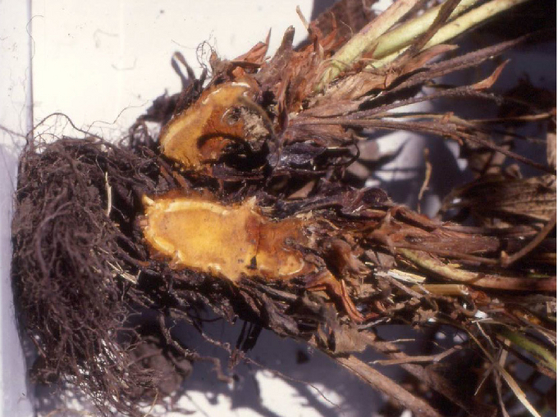

Rhizomfäule
an
der
Erdbeerpflanze

**Host
plants**

Host
plants
besides
strawberry
are
e.g.
also
bee
lover*(Phacelia*),
field
bean,
corn,
bush
berries
as
well
as
pome
and
stone
fruit.

**Distribution**

*P.
cactorum*
occurs
worldwide.

**Propagation
and
transmission**

Rhizome
rot
is
more
prevalent
on
cool,
moist
sites
or
in
years
with
high
rainfall.
Permanent
forms
of
*P.
cactorum*
can
survive
in
the
soil
for
years
without
a
host
plant.

In
spring,
strawberries
are
particularly
susceptible
to
rhizome
rot
infestation
because
the
plant
is
under
stress
from
growth,
flower
and
fruit
development.
The
same
pathogen
that
causes
rhizome
rot
is
also
responsible
for
leathery
berry
rot.

**Economic
importance**

Rhizome
rot
is
one
of
the
most
important
diseases
of
strawberries
and
can
lead
to
large
losses
under
suitable
conditions.
Due
to
the
persistence
of
the
pathogens
in
the
soil,
replanting
strawberries
should
be
avoided.

**Phytosanitary
status**

*Phytophthora
cactorum*
is
a
Union
regulated
non-quarantine
pest.

**Prevention
and
control**

* Heavy
  and
  wet
  soils
  should
  be
  avoided
  for
  strawberry
  production,
  if
  necessary
  provide
  drainage
  of
  wet
  soils.
  Planting
  on
  embankments
  is
  recommended
  or
  contact
  with
  the
  soil
  should
  be
  avoided
  by
  straw
  bedding.
* The
  introduction
  of
  green
  manure
  or
  other
  organic
  matter
  helps
  to
  improve
  the
  soil
  structure.
* It
  is
  also
  recommended
  to
  plant
  the
  following
  tolerant
  varieties:
  "Florence",
  "Pandora",
  "Symphony",
  "Pegasus",
  "Darselect",
  "Everest",
  "Bolero",
  "Tango",
  "Charlotte",
  "Camarosa",
  "Aromas",
  "Marmolada".

**Specialist
information**

**Projects**

[ERA-NET
EUPHRESCO
II:
Evaluation
and
testing
of
pathogens
on
strawberries](https://dafne.at/projekte/spat)

**Services**

[Plant
Health
Services](en/plant/plant-health/plant-health-information)