|  |  |
| --- | --- |
| Logo AGES | |
| Peach twig borer | |
|  |  |
| 30.04.2025 11:10 Uhr | |

**Peach
twig
borer**

**Anarsia
lineatella**

Last
change:
12.07.2022

**Profile**

The
peach
moth
is
a
major
damaging
butterfly
on
peach
and
apricot.
The
caterpillars
attack
the
shoot
tips
and
feed
in
the
fruit,
where
they
destroy
the
pulp
and
make
the
fruit
inedible.

**Appearance**

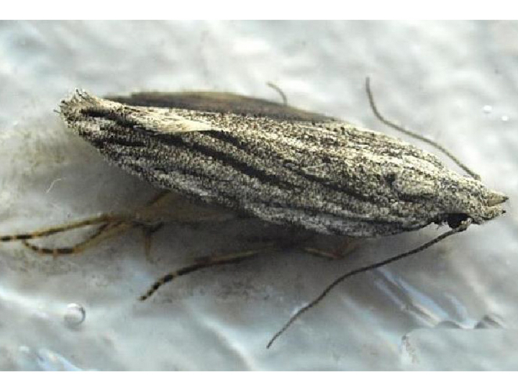

Adulte
Pfirsichmotte

The
moths
of
the
peach
moth*(Anarsia
lineatella*)
are
gray
and
about
14
mm
long.
They
are
characterized
by
lanceolate
forewings
with
small
black
dots
as
well
as
lighter
hindwings.

The
larvae
(caterpillars)
are
brown
with
light
pink
intersegmental
coloration
and
black
head
coloration.
The
intersegmental
coloration
makes
them
look
like
ringed
("zebra
caterpillar").
They
can
grow
up
to
12
mm
long.

**Biology**

The
peach
moth
belongs
to
the
palp
moth
family
(Gelechiidae).

The
activity
of
the
peach
moth
begins
in
spring
when
the
overwintering
young
larvae
(caterpillars,
second
larval
stage)
move
from
the
protective
cocoons
in
branch
forks
or
bark
hiding
places
to
the
fresh
shoots.
They
bore
into
the
shoots,
feed
downward
in
the
pith,
destroying
several
shoots
in
the
process
of
damage.

For
pupation,
they
prefer
to
spin
themselves
into
folded
leaves.
One
to
two
weeks
later,
the
first
folding
hatch
occurs,
which
can
be
the
case
in
the
Austrian
peach-growing
region
from
about
mid-May.
The
moths
are
crepuscular
and
nocturnal.
The
peak
of
the
flight
phase
of
the
first
generation
is
around
June.

The
females
of
this
generation
usually
lay
their
eggs
singly
on
the
underside
of
the
leaves.
From
there,
the
hatching
larvae
(caterpillars)
move
to
the
fruit
to
bore
in
and
feed
under
the
fruit
skin.
If
no
or
only
few
fruits
are
present,
shoot
tips
are
infested
again.
Pupation
occurs
on
fruit
stalks
or
between
leaves.
The
females
of
the
following
generation,
with
flight
peak
about
August,
lay
the
eggs
partly
already
on
bark
places,
because
the
hatching
caterpillars
form
the
overwintering
generation.

**Damage
symptoms**

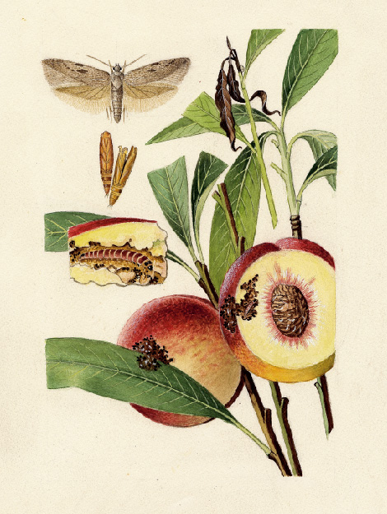

Pfirsichmotte
Schadbild

Infested
shoot
tips
wilt,
dry
up
and
often
show
a
characteristic
flag-like
appearance.
On
infested
fruit,
dark,
sunken
areas
can
be
seen
on
the
fruit
skin,
as
well
as
drops
of
congealed
liquid
(gum
flow)
and
brown
fecal
crumbs.

In
the
fruit
just
below
the
skin,
the
flesh
is
destroyed,
interspersed
with
feces
and
putrid;
larvae
(caterpillars)
may
be
found.
Cocoons
or
pupae
may
be
spotted
on
the
fruit
or
even
spun
between
leaves.

Due
to
increased
sunlight,
which
leads
to
earlier
ripening
of
the
fruits,
the
upper
tree
sections
often
show
a
higher
infestation.

The
symptoms
can
be
confused
with
those
of
the
[peach
moth](en/plant/plant-health/pests-from-a-to-z/oriental-fruit-moth)*(Grapholita
molesta*),
for
example.

**Host
plants**

The
main
host
plants
of
the
peach
moth
are
apricot*(Prunus
armeniaca*)
and
peach*(P.
persica*).
However,
it
can
also
become
damaging
on
a
number
of
other
fruit
crops.
These
include
plum*(Prunus
domestica*),
damson*(Prunus
dom*
estica
subsp.
*domestica*),
apple*(Malus*
spp.)
and
pear*(Pyrus*
spp.).

**Distribution**

The
peach
moth
is
of
Euro-Asian
origin
and
is
found
in
the
temperate
climate
regions
of
Europe,
especially
in
Spain,
France
and
Italy.
However,
it
also
occurs
in
North
Africa,
North
America
and
Asia
(especially
in
the
Middle
East).

**Economic
importance**

The
peach
moth
can
occur
as
a
dangerous
pest
in
peach
crops
and
nurseries
(annual
grafting)
and
cause
considerable
shoot
and
fruit
damage.

In
surveys
in
Austria
(cf.
Schildberger
et
al.
2005),
fruit
infestation
by
the
peach
moth
on
peaches
and
plums
was
detected
in
addition
to
shoot
infestation.
The
proportion
of
peach
moth
larvae
detected
on
peaches
was
usually
higher
than
that
of
the
peach
moth.
In
plums,
on
the
other
hand,
only
isolated
peach
moth
larvae
were
found,
while
plum
moth
and
peach
moth
were
found
in
greater
numbers.

**Prevention
and
control**

* Detection
  of
  occurrence
  (monitoring,
  prevention)
  as
  well
  as
  to
  determine
  treatment
  dates
  by
  traps
  (e.g.
  delta
  traps)
  to
  catch
  the
  adults
  using
  attractants
  (pheromones).
* Hygiene
  in
  the
  orchard:
  regular
  removal
  and
  harmless
  destruction
  of
  infested
  plant
  material
  (remove
  infested
  shoots
  and
  fruits
  while
  the
  larvae
  are
  still
  in
  them)
* Plant
  protection
  products
  against
  this
  pest
  are
  listed
  in
  the
  [register
  of
  plant
  protection
  products
  approved
  in
  Austria](https://www.baes.gv.at/zulassung/pflanzenschutzmittel/pflanzenschutzmittelregister/).

**Specialized
information**

**Publications**

Schildberger,
B.,
Polesny,
F.,
Rupf,
O.,
2005.
Observations
on
the
occurrence
of
peach
moth
and
peach
curculio
in
Austrian
orchards.
Mitteilungen
Klosterneuburg
55,
244-251.

**Links**

[Information
from
the
EPPO
on
the
peach
moth](https://gd.eppo.int/taxon/ANARLI)

[Information
of
the
fruit
growing
warning
service](https://obstwarndienst.lko.at/2456/Pfirsichwickler-und-Pfirsichmotte)

**Services**

[Plant
Health
Services](en/plant/plant-health/plant-health-information)