Pea necrotic yellow dwarf virus

06.05.2024 12:47 Uhr

Pea
necrotic
yellow
dwarf
virus

Pea
necrotic
yellow
dwarf
virus
Last
change:
09.05.2023

Profile
Pea
necrotic
yellow
dwarf
virus
(PNYDV)
belongs
to
the
nanoviruses
and
infects
legumes,
such
as
peas,
field
beans,
vetches,
lentils
and
chickpeas.
PNYDV
is
transmitted
by
aphids,
mainly
the
green
pea
aphid
and
black
bean
aphid.
If
infection
occurs
early
in
plant
development,
it
can
result
in
enormous
yield
losses
and
even
total
failure.

Biology
Nanoviruses
are
very
small
viruses
relative
to
other
viruses
that
cause
plant
diseases,
and
their
genetic
information
consists
of
DNA.
The
three
nanovirus
species
detected
so
far
in
Central
Europe
show
genetically
large
differences
compared
to
the
previously
known
nanoviruses.
The
nanovirus
species
mainly
detected
in
Austria
is
the
so-called
Pea
necrotic
yellow
dwarf
virus
(PNYDV).

Damage
symptoms
Early
infestation
with
PNYDV
is
manifested
by
stunted
plants
with
often
significantly
reduced
leaves
and
shortened
shoot
axes
(internodes),
as
well
as
reduced
root
and
nodule
formation.
Leaves
turn
yellow
and
are
sometimes
curled
upward,
and
shoot
tips
may
die.
On
some
crops
(lentil,
chickpea),
red
discoloration
can
also
be
observed
in
some
cases.
Flower
and
pod
set
is
low,
and
grain
formation
is
poor.
In
field
beans,
late-infested
plants
can
reach
normal
growth
heights
and
pod
set,
but
are
strongly
chlorotic.
So-called
infestation
nests,
which
are
roundish
areas
in
the
stands
with
infected,
yellow
and
dwarfed
plants,
are
typical.
In
field
beans,
distressed
plants
with
black
stems
are
also
found
in
the
infestation
nests.
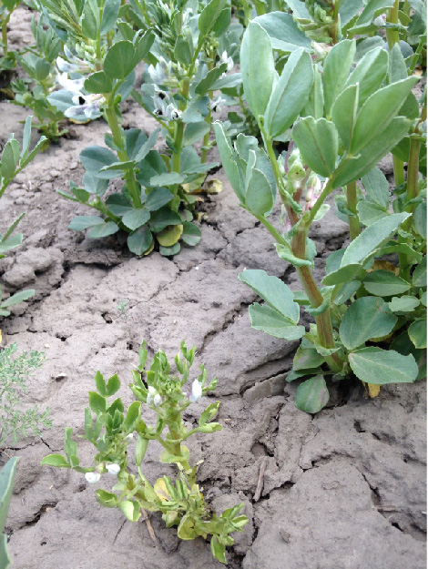
Im
Vordergrund
eine
mit
dem
Pea
necrotic
yellow
dwarf
virus
(PNYDV)
infizierte
Ackerbohne,
im
Hintergrund
gesunde
Pflanzen
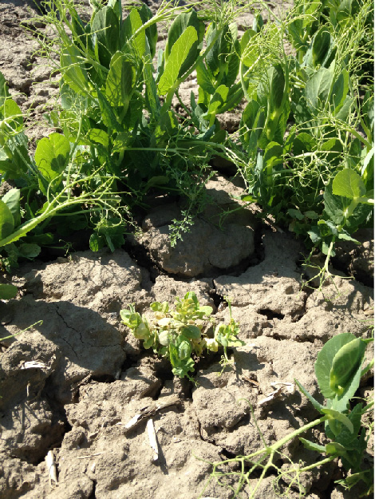
Im
Vordergrund
eine
mit
dem
Pea
necrotic
yellow
dwarf
virus
(PNYDV)
infizierte
Winterackererbse,
im
Hintergrund
gesunde
Erbsenpflanzen

Host
plants
In
four-year
trials,
natural
infestation
with
PNYDV
was
detected
in
Austria
on
pea
(summer
and
winter
field
pea,
green
pea,
pelucca),
field
bean
(summer
and
winter
field
bean),
lentil
(summer
and
winter
lentil),
chickpea,
vetch,
Pannonian
vetch
(Vicia
pannonica),
forage
vetch(V.
sativa),
and
rough
vetch(V.
hirsuta).
Soybean,
alfalfa,
red
and
white
clover,
or
Phaseolus
beans
are
not
considered
host
plants.

Distribution
Nanoviruses
were
first
known
in
warmer
regions,
such
as
North
and
East
Africa,
the
Middle
East,
Asia
and
Australia.
There,
they
cause
massive
yield
losses
in
various
legumes,
such
as
field
beans,
lentils
or
chickpeas,
at
periodic
intervals.
In
2009,
PNYDV
was
detected
for
the
first
time
in
pea
stands
in
Germany,
and
in
2010
for
the
first
time
in
Austria.
Since
2013,
typical
symptoms,
such
as
upsetting
and
yellowing
in
peas
and
field
beans,
have
been
repeatedly
detected
in
Austria,
and
PNYDV
has
been
detected.
An
almost
area-wide,
diagnostically
proven
infestation
with
PNYDV
in
peas
and
field
beans
occurred
for
the
first
time
in
2016,
confirming
that
the
spread
of
this
virus
and
also
its
danger
for
domestic
legume
cultivation
is
high.
So
far,
PNYDV
has
been
detected
not
only
in
Germany
and
Austria,
but
also
in
Denmark,
the
Netherlands,
the
Czech
Republic,
Hungary
and
Serbia.

Propagation
and
transmission
Nanoviruses
are
only
transmitted
by
aphids
as
vectors.
The
green
pea
aphid
and
the
black
bean
aphid
are
the
most
important
vectors.
Nanoviruses
cannot
be
transmitted
mechanically
(via
touch)
or
via
the
seed.

Economic
importance
In
addition
to
yield
losses,
early
infections
can
also
lead
to
total
failures.
In
Austria,
massive
losses
due
to
PNYDV
were
recorded
in
green
pea,
grain
pea,
winter
grain
pea,
field
bean
and
winter
lentil
in
recent
years
(especially
2016
and
2018).

Prevention
and
control
- If
plants
are
infected
with
nanoviruses,
as
with
all
plant
pathogenic
viruses,
no
curative
(=healing)
measures
are
possible.
- Since
PNYDV
is
transmitted
neither
mechanically
nor
via
seed,
but
only
via
aphids,
the
only
control
option
is
indirect
and
consists
of
preventive
control
of
the
aphids
-
see
also
the
warning
service
of
the
chambers
of
agriculture.
- In
summer
plantings,
it
is
advisable
to
plant
varieties
as
early
as
possible
so
that
the
plants
are
as
developed
as
possible
when
infected
with
the
virus.
In
winter
tillage,
late
cultivation
is
advisable
to
keep
infections
low
in
the
fall.
- Studies
have
shown
that
mixed
cropping
(such
as
field
bean/oats,
grain
pea/barley)
also
reduces
aphid
infestation
on
legumes.
- Legume
species
that
are
hardy
and
host
plants
for
PNYDV
provide
the
virus
reservoir
for
infections
at
the
beginning
of
a
new
growing
season.
These
legume
species
should
either
be
avoided
in
pea
and
arable
regions,
or
turned
over
in
time
if
they
have
not
frozen
off
in
the
spring.

Specialized
information
In
research
projects,
we
deal
with
the
epidemiology
of
PNYDV
and
with
possible
measures
and
control
strategies.
The
warning
service
of
the
Chamber
of
Agriculture
has
been
supported
by
us
since
2017
with
aphid
monitoring
and
virus
testing.
In
the
DaFNE
project
"NANOVIR
"
(2018
to
2020),
the
natural
host
plants
of
PNYDV
and
the
role
of
different
aphid
vectors
in
Austria
were
determined.
Furthermore,
different
spray
variants
and
a
mixed
crop
cultivation
in
organic
field
bean
were
investigated.
In
the
CORNET
project
"SPITFIRE
"
(Dec.
2021
to
2024,
scientific
leadership:
Julius
Kühn-Institut
Braunschweig),
resistance
to
PNYDV
in
pea
is
being
sought.
Our
nanovirus
platform
gives
stakeholders
and
affected
persons
the
opportunity
to
exchange
information
on
the
nanovirus
problem
on
an
annual
basis.

Services
We
detect
nanoviruses
and
the
PNYDV
in
plants
by
molecular
biology.
If
required,
the
nanovirus
species
can
also
be
determined
by
means
of
sequence
analysis.
An
analysis
usually
takes
two
working
days
(about
four
working
days
for
sequence
analysis).
Plant
Health
Services

