|  |  |
| --- | --- |
| Logo AGES | |
| Oriental fruit moth | |
|  |  |
| 26.07.2025 03:59 Uhr | |

**Oriental
fruit
moth**

**Grapholita
molesta**

Last
change:
04.11.2024

**Profile**

The
peach
moth,
sometimes
called
the
peach
shoot
borer,
is
a
major
damaging
butterfly
on
peaches
and
apricots,
but
also
attacks
other
stone
and
pome
fruit
crops.
The
caterpillars
destroy
shoot
tips
and
pulp,
making
the
fruit
inedible.

**Appearance**

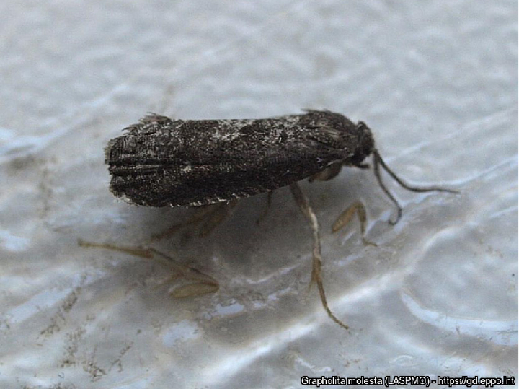

Pfirsichwickler
-
erwachsenes
Männchen

The
moths
of
the
peach
moth*(Grapholita
molesta*)
are
dark
gray
in
color
and
hold
their
wings
roof-like
over
the
body
when
at
rest.
When
these
are
spread
out,
they
reach
a
wingspan
of
10
-
16
mm.
Peach
moths
can
be
confused
with
moths
of
other
moth
species
(e.g.
[plum
moth](en/plant/plant-health/pests-from-a-to-z/plum-fruit-moth),
*Grapholita
funebrana*).
An
exact
determination
can
only
be
made
in
the
laboratory
using
microscopic
preparations
or
molecular
biology.

The
caterpillars
reach
a
length
of
up
to
12
mm
and
are
reddish
in
color,
with
the
head
capsule
brown
in
color.

The
eggs
are
about
0.7
mm
in
size,
initially
transparent
and
later
whitish
to
yellow
in
color.

**Biology**

The
peach
moth
is
assigned
to
the
moth
family
(Tortricidae).

After
hibernation
in
the
last
larval
stage,
which
survives
protected
in
a
cocoon
in
bark
or
in
crevices
in
the
ground,
the
larvae
(caterpillars)
pupate
at
temperatures
above
10
°C.
The
first
generation
of
moths
(adults)
emerge
from
the
cocoon
at
the
end
of
April.
From
the
pupae,
the
moths
(adults)
of
the
first
generation
hatch
around
the
end
of
April.
Soon
after
hatching,
females
begin
laying
eggs
on
leaves,
near
the
shoot
tips
of
young
twigs,
or
on
smooth-skinned
fruit.
Each
female
can
lay
up
to
200
eggs.
The
egg
stage
lasts
about
three
to
five
days,
but
somewhat
longer
at
temperatures
below
20°C.
The
caterpillars
that
hatch
from
these
eggs
feed
and
develop
mostly
in
the
shoots
of
young
twigs
at
the
beginning
of
the
season,
but
later
also
on
or
in
fruits.
Pupation
occurs
in
cocoons
on
fruit,
in
twig
axils,
or
under
pieces
of
bark.
The
adult
caterpillars
of
the
last
generation
position
the
cocoons
in
uneven
places
on
the
trunk,
on
twigs,
dried
fruit,
or
cracks
in
the
ground
below
the
host
tree
to
overwinter.

The
duration
of
development,
as
well
as
the
number
of
generations,
depends
on
temperature
and
therefore
varies
regionally.
The
three
generations
occurring
in
Austria
have
their
flight
peaks
in
May,
June
and
September,
whereby
the
third
generation
is
the
strongest
and
can
therefore
cause
increased
infestation,
especially
for
late-maturing
varieties.

**Damage
symptoms**

Infested
shoot
tips
wilt,
dry
out
and
often
show
a
characteristic
flag-like
appearance.
In
some
cases,
the
plants
react
with
increased
secondary
shoot
formation,
which
can
lead
to
a
bushy
appearance
in
the
case
of
heavy
infestation.

Infested
fruits
may
show
external
feeding
marks
as
well
as
emerging
and
solidified
liquid
droplets
(gum
flow).
In
calyx
and
peduncle
bays,
or
at
the
point
of
contact
between
two
fruits,
brownish
fecal
crumbs
or
pits
may
be
found.
The
flesh
of
infested
fruit
is
partially
destroyed.

Damage
symptoms
caused
by
the
peach
shoot
moth
can
be
confused
with
those
of
the
[peach
moth](en/plant/plant-health/pests-from-a-to-z/peach-twig-borer)*(Anarsia
lineatella*).

**Host
plants**

The
main
host
plants
of
the
peach
moth
are
apricot*(Prunus
armeniaca*)
and
peach*(P.
persica*).
However,
the
peach
moth
can
also
be
damaging
to
other
stone
and
pome
fruit
crops,
including
cherry*(P.
avium*),
plum*(Prunus
domestica*),
plum*(Prunus
domestica*
subsp.
*domestica*),
and
other
*Prunus
species*,
as
well
as
apple
(*Malus*
spp.)
and
pear*(Pyrus*
spp.).
In
addition,
wild
and
ornamental
plants
(such
as
*Cotoneaster*
spp.
&
*Crataegus*
spp.)
were
also
found
to
be
host
plants.

**Distribution**

Starting
in
the
Far
East,
the
peach
moth
spread
to
Europe
via
Australia
and
America.
Today
it
occurs
in
the
temperate
regions
of
all
continents
and
is
widespread
in
Europe.

**Economic
importance**

In
investigations
in
Austria
(cf.
Schildberger
et
al.
2005),
fruit
infestation
by
the
peach
moth
was
found
on
peaches,
plums
and
apples,
in
addition
to
infestation
of
shoot
tips.
However,
depending
on
the
type
of
fruit,
the
proportion
of
peach
moth
larvae
detected
was
usually
lower
than
that
of
other
comparable
pests
(e.g.
peach
moth,
plum
moth,
codling
moth).

**Prevention
and
control**

* To
  detect
  the
  occurrence
  (monitoring,
  prevention)
  and
  to
  determine
  treatment
  dates:
  Traps
  (e.g.,
  delta
  traps)
  are
  used
  to
  capture
  adults
  using
  attractants
  (pheromones
  or
  feeding
  baits).
  Note
  the
  similarity
  of
  the
  pheromone
  to
  that
  of
  the
  [plum
  moth](en/plant/plant-health/pests-from-a-to-z/plum-fruit-moth)*(Grapholita
  funebrana*).
  This
  may
  cause
  simultaneous
  captures
  of
  this
  species
  as
  well.
  The
  moths
  of
  the
  peach
  moth
  and
  the
  plum
  moth
  are
  difficult
  to
  distinguish
  morphologically
  (genital
  preparation
  required).
* Variety
  selection:
  Late-maturing
  varieties
  are
  more
  likely
  to
  be
  affected
  by
  damage
  because
  they
  are
  infested
  by
  the
  third
  and
  strongest
  generation
* Hygiene
  in
  the
  orchard
  can
  reduce
  the
  extent
  of
  infestation
  by
  regular
  removal
  of
  infested
  plant
  material
  (destroy
  infested
  plant
  material
  without
  damage)
* Plant
  protection
  products
  against
  this
  pest
  are
  listed
  in
  the
  [register
  of
  plant
  protection
  products
  approved
  in
  Austria](https://www.baes.gv.at/zulassung/pflanzenschutzmittel/pflanzenschutzmittelregister/).

**Specialized
information**

**Publications**

Schildberger,
B.,
Polesny,
F.,
Rupf,
O.,
2005.
Observations
on
the
occurrence
of
peach
moth
and
peach
curculio
in
Austrian
orchards.
Mitteilungen
Klosterneuburg
55,
244-251.

**Links**

[Information
from
the
EPPO
on
the
peach
moth](https://gd.eppo.int/taxon/LASPMO)

[Information
of
the
fruit
growing
warning
service](https://obstwarndienst.lko.at/2456/Pfirsichwickler-und-Pfirsichmotte)

**Services**

[Plant
Health
Services](en/plant/plant-health/plant-health-information)