|  |  |
| --- | --- |
| Logo AGES | |
| Mulberry scale | |
|  |  |
| 09.05.2025 19:09 Uhr | |

**Mulberry
scale**

**Pseudaulacaspis
pentagona**

Last
change:
26.08.2024

**Profile**

The
mulberry
scale
insect,
sometimes
called
the
almond
scale
insect,
is
a
major
animal
pest
of
many
cultivated
and
ornamental
plants.
The
plants
are
prevented
from
developing
by
the
sucking
activity
of
the
animals,
which
occur
in
masses,
and
they
become
stunted
and
may
eventually
die.

**Appearance**

Characteristic
is
the
back
shield
of
the
adult
animals,
which
contributes
to
the
naming.

Both
in
the
juvenile
stages
as
well
as
in
the
adult
animals
a
pronounced
sexual
dimorphism
(=clear
differences
between
the
appearance
of
the
sexes)
is
shown:

**Males**:
they
live
only
a
short
time
as
adults,
but
here
they
also
form
winged
forms
(wingspan
up
to
1.5
mm)
and
are
attracted
to
mating
by
sex
attractants
of
the
females.
Before
that,
the
young
males,
which
usually
hatch
from
white
eggs,
are
distinguished
by
a
conspicuous
white
colored
longitudinal
oval
shield.
This
is
usually
easily
recognizable,
mainly
because
the
animals
stay
in
masses
on
the
infested
plant
parts.
After
hatching,
the
empty
shields
of
the
males
remain
behind.

**Females**:
They
usually
hatch
from
orange
eggs
and
are
less
conspicuous,
because
the
blister-shaped
animals
under
their
roundish-oval
shield
(white-beige
with
yellow-brown
center)
are
little
distinguishable
from
the
bark
of
their
host
plants.
With
their
protective
shield,
the
animals
reach
a
size
of
about
2
to
3
mm.

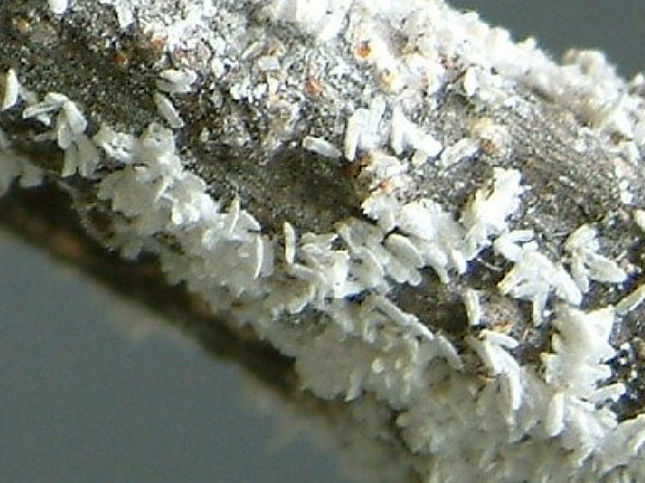

Befall
mit
männlichen
Maulbeerschildläusen

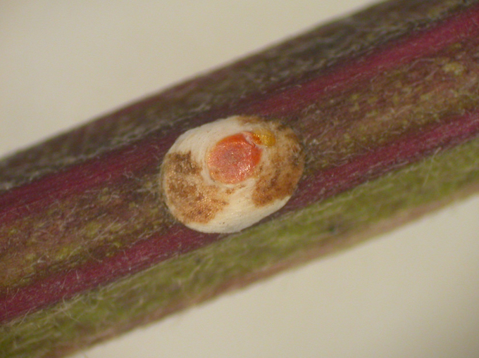

Weibliche
Maulbeerschildlaus

**Biology**

The
mulberry
scale
aphid
belongs
to
the
family
of
cover
scale
aphids
(Diaspididae).

The
hibernation
of
the
mulberry
scale
aphid
takes
place
as
a
fertilized
female
which
is
attached
to
the
wood
and
can
survive
very
low
temperatures
(e.g.
-18
°C).
From
May
onwards,
the
female
lays
about
100
-
150
eggs
under
the
scale,
the
orange
eggs
being
laid
before
the
white
eggs.
The
larvae
hatch
after
only
a
few
days,
but
like
all
developmental
steps,
it
is
temperature-dependent.
The
development
takes
place
above
a
temperature
threshold
of
approx.
10
°C.
The
0.2
mm
long
larvae
("crawlers")
are,
like
the
eggs
before,
sensitive
to
temperature
setbacks
in
spring.
They
pass
through
different
numbers
of
larval
stages
(depending
on
sex),
with
males
barely
moving
away
from
the
maternal
shield
during
this
period.
In
contrast,
the
female
larval
stages
are
very
mobile
in
the
first
hours
after
hatching
and
actively
seek
out
new
infestation
sites
on
the
plant,
where
they
attach
themselves.
This
phase
of
the
so-called
larval
run
takes
place
in
our
latitudes
around
the
first
half
of
June.
From
about
the
beginning
of
July,
the
first
generation
becomes
sexually
mature.

In
the
optimal
temperature
range,
at
about
25
°C
to
30
°C,
the
mulberry
scale
aphid
needs
less
than
two
months
for
the
development
of
a
generation.
After
mating
and
egg-laying,
the
larvae
of
the
second
generation
develop,
so
that
the
mating
flight
begins
again
around
late
summer/fall.
In
this
country,
the
mated
females
subsequently
overwinter,
while
in
other
areas
further
generations
can
be
formed
or,
under
cooler
climatic
conditions,
only
one
generation
can
develop.

**Damage
symptoms**

In
the
case
of
mass
occurrence
of
the
mulberry
scale
insect,
the
infested
parts
of
the
plant
(often
the
base
of
the
trunk
or
leading
branches)
look
as
if
they
have
been
dyed
white
or
whitewashed.
The
scale
remains
even
after
the
animals
die.
Several
layers
of
the
scales
can
also
form
on
top
of
each
other,
which
can
lead
to
crust-like
structures
on
the
plants.
Sometimes
the
bark
also
breaks
open
and
parts
of
the
plant
or
the
entire
plant
dies.

Damage
to
fruit
has
also
been
documented,
for
example
on
peaches
in
Germany.
In
massive
infestations,
fruit
deformations
occurred
there.
A
red
halo
formed
around
the
sucking
spots,
and
white
shields
of
the
males
were
usually
found
inside
the
spots.

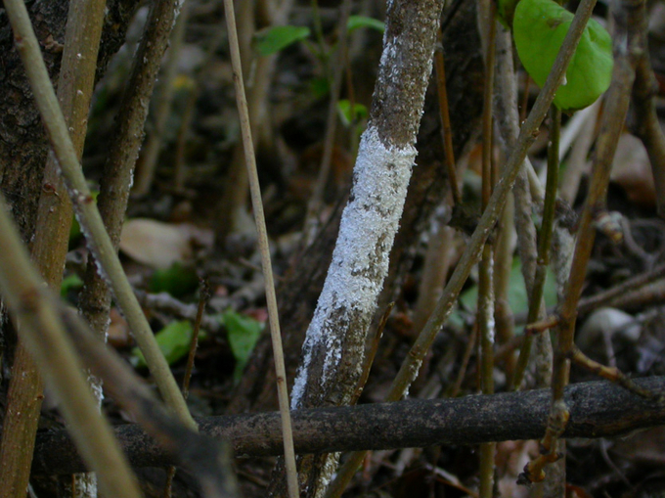

Befall
einer
Wirtspflanze
mit
Maulbeerschildläusen

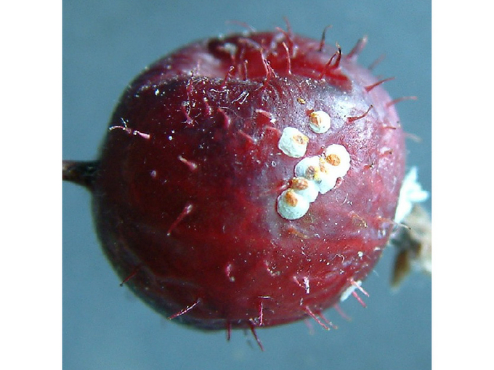

Befallene
Frucht
einer
Wirtspflanze

**Host
plants**

The
mulberry
scale
aphid
is
very
polyphagous
and
can
feed
on
well
over
a
hundred
host
plants
from
many
different
plant
families.
It
is
considered
an
important
pest
of
rose
plants
(Rosaceae),
but
also
occurs
on
various
fruit
crops,
ornamental
and
wild
plants
of
other
families.

Of
the
native
fruit
crops,
various
soft
fruit
crops
such
as
currants*(Ribes*
spp.),
raspberries
and
blackberries*(Rubus*
spp.),
various
stone
fruit
crops
such
as
peach,
apricot,
cherry
et
al.a.
(div.
*Prunus*
spp.)
as
well
as
mulberry
(*Morus*
spp.),
kiwi*(Actinidia*
sp.),
pear
(*Pyrus*
sp.),
walnut*(Juglans*
sp.),
grapevine*(Vitis*
sp.)
and
others.
The
following
is
a
selection
from
the
many
other
potential
host
plants,
from
ornamental
and
wild
plants:
Maple*(Acer*
sp.),
mountain
ash
(*Sorbus*
sp.),
oak
(*Quercus*
sp.),
ash*(Fraxinus*
sp.),
lilac
(*Syringae*
sp.),
hazel
(*Corylus*
sp.),
weeping
birch
(*Betula*
sp.),
dogwood
(*Cornus*
sp.),
hedge
myrtle
(*Lonicera*
sp.),
cherry
laurel
(*Prunus*
sp.),
linden*(Tilia*
sp.),*mahonia
(Mahonia*
sp.),
oleander
(*Nerium*
sp.),
pipe
bush
(*Philadelphus*
sp.),*robinia
(Robinia*
sp.),
cordwood
(*Styphnolobium*
sp.),
spindle
bush
(*Euonymus*
sp.),
trumpet
tree
(*Catalpa*
sp.),
willow
(*Salix*
sp.),
ornamental
apple
(*Malus*
sp.),
dwarf
loquat
(*Cotoneaster*
sp.).

**Distribution**

Originating
from
eastern
Asia,
the
species
is
now
found
on
all
continents
and
in
diverse
climatic
zones
(tropical,
subtropical,
temperate).
Meanwhile
it
has
been
found
in
most
countries
of
Southern
and
Central
Europe.
In
Austria,
it
was
found
to
be
the
most
common
species
during
shield
aphid
surveys
in
various
parks
in
Vienna
in
2008.

**Propagation
and
transmission**

Small-scale
dispersal
occurs
primarily
through
the
mobile
larval
stages
(crawlers;
active
or
passive
through
wind
dispersal).
More
important
for
the
large-scale
spread,
however,
is
the
spread
with
infested
plant
material
(such
as
nursery
stock).

**Economic
importance**

The
mulberry
scale
aphid
is
a
difficult
pest
to
control
on
peach,
nectarine,
apricot,
citrus,
almond,
currant
and
kiwi,
especially
in
southern
Europe.
Internationally,
for
example
in
Turkey
or
in
the
south
of
the
USA,
it
is
considered
one
of
the
most
important
animal
pests
of
peach.

**Prevention
and
control**

* Use
  of
  traps
  for
  population
  monitoring
  (to
  detect
  the
  flight
  of
  males).
* Infestation
  monitoring
  at
  harvest
  based
  on
  fruit
  damage
  (for
  peach)
* Mechanical
  removal
  of
  scale
  insects:
  + Brushing
    off
    (by
    hand)
    /
    careful
    blasting
    with
    the
    aid
    of
    a
    high-pressure
    cleaner
    (e.g.
    in
    older
    peach
    plants;
    after
    leaf
    fall
    in
    autumn
    until
    before
    budbreak
    in
    spring,
    but
    not
    during
    frost)
  + Grubbing
    up
    or
    pruning
    back
    heavily
    infested
    plant
    parts
    (during
    dormancy,
    before
    budbreak)
    -
    Destroy
    material
    without
    causing
    damage
    (possible
    state
    regulations
    must
    be
    observed!)
* Protection/support
  of
  natural
  enemies
  (chalcid
  wasps
  and
  predators;
  if
  necessary,
  leave
  cut
  material
  in
  the
  plant
  until
  they
  overwinter)
* Plant
  protection
  products
  for
  the
  control
  of
  scale
  insects
  are
  listed
  in
  the
  [register
  of
  plant
  protection
  products
  approved
  in
  Austria](https://www.baes.gv.at/zulassung/pflanzenschutzmittel/pflanzenschutzmittelregister/).

**Specialized
information**

**Publikationen**

Malumphy,
C.,
Kahrer,
A.,
2011.
New
data
on
the
scale
insects
(Hemiptera:
Coccoidae)
of
Vienna,
including
one
invasive
species
new
for
Austria.
Beiträge
zur
Entomofaunistik
12,
47-60.

**Links**

[Information
of
the
EPPO
on
the
mulberry
scale
insect](https://gd.eppo.int/taxon/PSEAPE)

[Information
from
LTZ
Augustenberg
(plant
health
advice)](https://ltz.landwirtschaft-bw.de/pb/site/pbs-bw-mlr/get/documents_E849898493/MLR.LEL/PB5Documents/ltz_ka/Service/Schriftenreihen/Hinweise%20zur%20Pflanzengesundheit/Maulbeerschildlaus_DL/Pflanzengesundheit_Maulbeerschildlaus.pdf)

**Services**

[Plant
Health
Services](en/plant/plant-health/plant-health-information)