|  |  |
| --- | --- |
| Logo AGES | |
| Leaf spot on celery | |
|  |  |
| 30.04.2025 08:10 Uhr | |

**Leaf
spot
on
celery**

**Cercospora
apii**

Last
change:
17.11.2021

**Profile**

The
leaf
spot
fungus
*Cercospora
apii*
occurs
on
celery
during
prolonged
periods
of
higher
temperatures
during
the
summer
months.
Brown
spots
appear
on
the
leaves
of
infested
plants,
which
eventually
dry
out.

**Damage
symptoms**

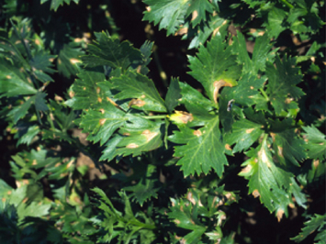

Erste
Symptome
an
den
äußeren,
älteren
Sellerieblättern

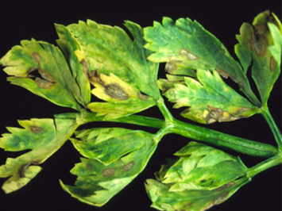

Symptome
an
den
Blättern

The
first
symptoms
are
the
appearance
of
small,
roundish,
yellowish
to
light
brown
spots
on
the
leaves,
which
rapidly
increase
in
size.
The
spots
dry
out
and
turn
an
intense
brown.
If
the
leaf
spots
flow
together,
the
leaves
wilt
and
eventually
wither.
On
the
surface,
symptoms
may
be
initially
confused
with
those
of
Septoria
leaf
spot
disease.
*Cercospora
apii*
usually
appears
earlier
than
*Septoria
apiicola*.

**Host
plants**

In
addition
to
celery*(Apium
graveolens*),
other
host
plants
include
wild
carrot
(*Daucus
carota*)
and
parsnip*(Pastinaca
sativa*).

**Distribution**

The
fungus
is
common
in
celery-producing
countries
worldwide.

**Propagation
and
transmission**

*Cercospora
apii*
is
seed-borne
and
can
persist
on
infected
plant
debris
incorporated
into
the
soil.
Spores
are
spread
by
wind,
water
droplets,
field
operations,
and
machinery.

Temperatures
between
15
and
30
°C
promote
the
occurrence
of
*Cercospora
apii*,
but
the
fungus
spreads
preferentially
at
temperatures
between
22
and
28
°C.

**Economic
importance**

*Cercospora
apii*
occasionally
occurs
on
celery,
but
due
to
its
higher
temperature
requirements
(over
longer
periods)
it
has
so
far
only
gained
economic
importance
in
Austria
in
warm
summers.

**Prevention
and
control**

* Use
  of
  pest-free
  seed
* Adherence
  to
  a
  crop
  rotation
  of
  at
  least
  four
  years
* Deep
  plowing
  of
  crop
  residues
* Controlled
  irrigation

If
this
fungus
becomes
more
important
on
celery
due
to
changed
weather
conditions*(Cercospora
apii*
prefers
higher
humidity
and
temperatures
between
15
and
30
°C),
the
area
of
spread,
the
demands
of
the
pathogen,
the
infestation
intensity
and
frequency
as
well
as
possible
modified
countermeasures
must
be
surveyed.

**Services**

[Plant
Health
Services](en/plant/plant-health/plant-health-information)