|  |  |
| --- | --- |
| Logo AGES | |
| Knotweed | |
|  |  |
| 03.07.2025 12:48 Uhr | |

**Knotweed**

**Reynoutria
spp.**

Last
change:
10.09.2024

**Profile**

Perennial
knotweed
originates
from
Asia
and
is
a
3-4
m
tall
perennial
species
that
spreads
mainly
on
open
banks.
There
it
causes
erosion
of
the
soil
and
does
not
allow
other
plants
due
to
its
dense
growth.

**Appearance**

Three
species
are
distinguished
among
the
perennial
knotweeds:

**Japanese
knotweed***(Reynoutria
japonica*
Houtt.)
is
a
dioecious
perennial
up
to
3
m
tall
with
stout,
glabrous,
hollow
stems
that
are
usually
tinged
dark
red.
The
thick
rhizomes
are
characteristic.
The
plant
forms
numerous
leaf
shoots
from
the
rhizomes.
The
leaves
are
alternate
and
have
a
family-typical
ochrea
(tute;
membranous
tube
enclosing
the
base
of
the
following
stem
limb).
Leaves
are
broadly
ovate
(max.
20
cm
long),
narrowly
acuminate
at
the
end,
and
truncate
at
right
angles
or
slightly
rounded
at
the
base.
The
inflorescences
are
many-flowered,
the
flowers
small
and
white.
The
fruitlets
are
triangular
and
winged.

**Sakhalin
kn**
otweed*(Reynoutria
sachalinensis*
[F.
Schmidt]
Nakai)
grows
up
to
4
m
tall.
Unlike
Japan
knotweed,
the
leaves
are
up
to
30
cm
tall
and
the
leaf
blade
is
heart-shaped
rounded
at
the
base.

The
**bastard
knotweed***(Reynoutria
x
bohemica*
Chrtek
&
Chrtková)
occupies
an
intermediate
position
in
many
characteristics.

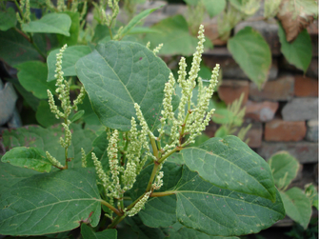

Japan-Knöterich
in
der
Blüte

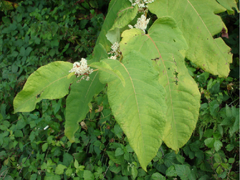

Sachalin-Knöterich
in
der
Blüte

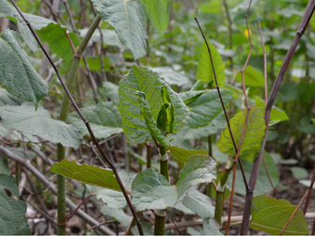

Austrieb
im
Frühjahr

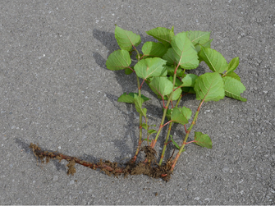

Rhizom
des
Staudenknöterichs

**Distribution**

Japan
perennial
knotweed
and
Sakhalin
knotweed
originate
from
areas
in
East
Asia
(widespread
in
China,
Japan
and
Korea,
Russia
-Far
East).
Since
about
1950,
there
has
been
a
rapid
spread
in
Europe.
Large
stands
develop
mainly
on
wood-free
shorelines
or
under
the
canopy
of
woody
plants
that
accompany
the
shore.
Perennial
knotweed
invades
herbaceous
vegetation.
It
is
also
common
on
urban-industrial
wastelands
(railroads),
roadsides,
embankments.
It
grows
less
strongly
in
forests,
but
can
also
occur
permanently
here
if
there
is
sufficient
light.
Perennial
knotweed
is
increasingly
invading
arable
land.
Perennial
knotweed
spreads
mainly
vegetatively,
with
rhizome
fragments
being
carried
away
by
flowing
water
or
by
humans.

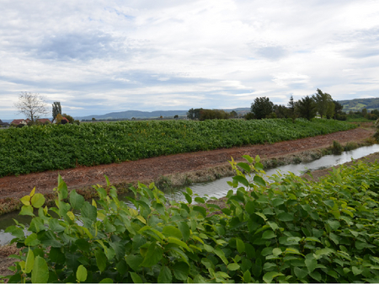

Staudenknöterich
entlang
eines
Flusses

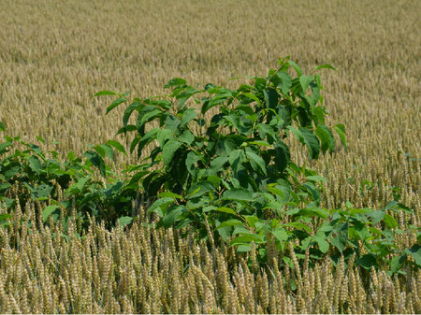

Staudenknöterich
in
einer
Ackerfläche

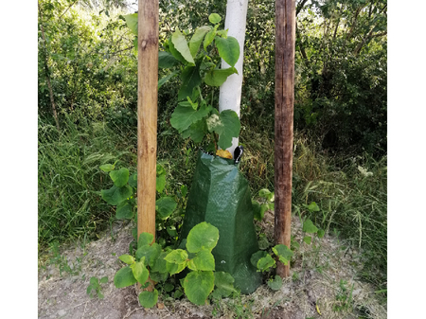

Staudenknöterich
in
einer
Baumpflanzung

**Economic
importance**

The
economic
consequences
of
knotweed
include
direct
damage
to
buildings
and
bank
stabilization
and
control
costs
on
banks,
on
railway
tracks
and
in
building
land,
and
in
agriculture.

Stands
on
the
banks
of
smaller
streams
are
especially
significant
for
conservation.
Stands
of
knotweed
are
very
closed
and
allow
very
limited
growth
of
other
plants.
This
results
in
alteration
of
the
landscape
and
selective
displacement
of
native
species
(including
butterbur,
stinging
nettle,
and
fence
bindweed).
There
is
an
increase
in
erosion
hazards
along
riparian
areas.
The
herbaceous
knotweed
dies
in
winter
and
the
low
fine
root
formation
means
that
the
soil
is
not
adequately
protected
in
the
event
of
flooding.

**Prevention
and
control**

Sustainable
control
of
knotweed
is
very
difficult,
costly
and
lengthy.
There
is
also
currently
no
consensus
on
the
"best
way"
to
control
knotweed
(see
links).

* Mowing:
  Frequent
  mowing
  (cutting)
  can
  reduce
  the
  growth
  and
  weaken
  the
  population.
  However,
  mowing
  is
  definitely
  viewed
  critically.
  If
  mowing
  is
  done
  improperly,
  the
  damage
  is
  greater
  than
  the
  benefit
  -
  spread
  is
  encouraged.
  Mowing
  can
  be
  done
  in
  various
  ways
  and
  with
  various
  tools
  (mowers,
  trimmers).
  However,
  the
  stems
  must
  be
  cut
  cleanly
  (individually)
  and
  disposed
  of
  properly.
  Then
  mowing/cutting
  is
  a
  relatively
  safe
  and
  simple
  control
  option.
  The
  cuttings
  should
  be
  hauled
  away
  and
  sent
  to
  a
  professional
  composting
  facility
  (above
  70°C),
  otherwise
  drying
  on
  sealed
  ground
  for
  several
  months
  is
  recommended.
  Several
  (>
  4)
  cuts
  per
  year
  at
  a
  height
  of
  40
  cm
  over
  several
  years
  (at
  least
  4)
  are
  recommended.
  Regular
  mowing
  is
  useful,
  for
  example,
  to
  ensure
  accessibility
  or
  visibility
  along
  a
  transportation
  infrastructure.
* Herbicides:
  the
  use
  of
  glyphosate
  is
  recommended,
  preferably
  at
  two
  dates
  per
  year
  (glyphosate
  in
  summer
  and
  autumn)
  or
  an
  annual
  application
  of
  glyphosate
  in
  autumn
  by
  stem
  injection
  at
  a
  dosage
  of
  65
  kg/ha
  or
  foliar
  spraying
  at
  a
  dosage
  of
  3.6
  kg/ha.
  However,
  these
  measures
  are
  complicated
  by
  the
  fact
  that
  in
  many
  habitats
  (e.g.
  along
  rivers)
  the
  use
  of
  glyphosate
  is
  not
  possible
  (no
  approval).
* Competitive
  vegetation:
  It
  is
  generally
  advisable
  to
  cover
  the
  ground
  with
  dense,
  shade-providing
  vegetation.
  Both
  grasses
  and
  woody
  plants
  act
  as
  competitors
  for
  perennial
  knotweed.
  In
  addition,
  this
  is
  a
  promising
  measure
  in
  combination
  with
  other
  methods
  (e.g.,
  mowing/cutting).
* Other
  various
  measures
  include
  covering
  with
  geotextiles
  or
  geomembranes
  or
  wire
  netting

**Links**

Jones,
D.,
Bruce,
G.,
Fowler,
MS.,
Law-Cooper,
R.,
Graham,
I.,
Abel,
A.,
Street-Perrott,
FA.,
Eastwood,
D.,
2018.
[Optimising
physiochemical
control
of
invasive
Japanese
knotweed](https://link.springer.com/article/10.1007/s10530-018-1684-5).
Biological
Invasions
20,
2091-2105.

Martin,
F-M.,
Dommanget,
F.,
Lavallée,
F.,
Evette,
A.,
2020.
[Clonal
growth
strategies
of
Reynoutria
japonica
in
response
to
light,
shade,
and
mowing,
and
perspectives
for
management](https://neobiota.pensoft.net/article/47511/).
NeoBiota
56,
89-110.

Jones,
D.,
Fowler,
MS.,
Hocking,
S.,
Eastwood,
D.,
2020a.
[Please
don’t
mow
the
Japanese
knotweed!](https://neobiota.pensoft.net/article/56935/)
NeoBiota
60,
19-23.

**Services**

[Plant
Health
Services](en/plant/plant-health/plant-health-information)