|  |  |
| --- | --- |
| Logo AGES | |
| Greenhouse whitefly | |
|  |  |
| 09.05.2025 19:37 Uhr | |

**Greenhouse
whitefly**

**Trialeurodes
vaporariorum**

Last
change:
18.01.2022

**Profile**

The
greenhouse
moth
scale
insect,
also
called
whitefly,
originates
from
East
Africa
and
is
found
in
Austria
on
numerous
greenhouse
crops.
Its
name
comes
from
the
fact
that
the
larvae
are
stuck
similar
to
scale
insects,
while
the
adult
insects
are
able
to
fly
like
small
white
moths.
In
addition
to
sucking
damage,
visual
impairment
of
the
plants
occurs
due
to
honeydew
excretion.

**Appearance**

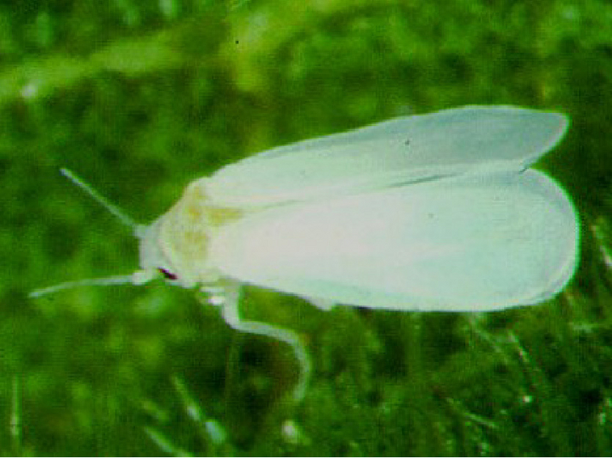

Adulte
Weiße
Fliege

The
adults,
about
2
mm
in
size,
have
two
pairs
of
wings
and
are
covered
with
fine
white
wax
dust.
They
usually
sit
well
protected
on
leaf
undersides
and
jump
away
by
means
of
their
hind
legs
when
disturbed,
after
which
a
flight
begins.

The
larvae
develop
through
four
scale-like
stages,
growing
to
about
0.8
mm
in
length.
The
first
larval
stage
is
still
freely
mobile
with
functional
extremities,
but
these
later
atrophy.
All
stages
are
predominantly
transparent
and
show
paired
yellow
spots
inside
the
body.
The
last
developmental
stage
(pseudopuparium)
looks
like
a
tiny
oval-shaped
box
with
vertical
walls
and
is
white
to
yellowish
in
color.

The
0.25
mm
long
spindle-shaped
eggs
are
anchored
to
the
undersides
of
younger
leaves
with
a
small
stalk
in
the
leaf,
through
which
they
are
supplied
with
moisture.
Freshly
laid,
they
are
white,
but
become
progressively
darker
during
their
development,
which
lasts
about
six
to
eight
days
(at
20
°C).

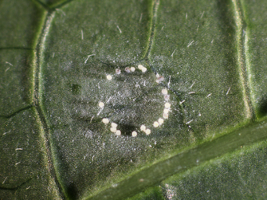

Eier
der
weißen
Fliege

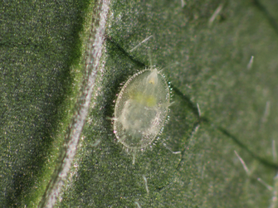

Weiße
Fliege
im
Larvenstadium

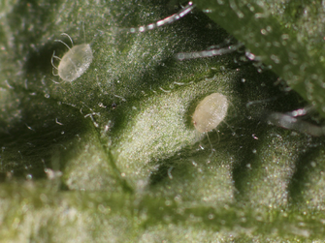

Pseudopuparium
der
Weißen
Fliege

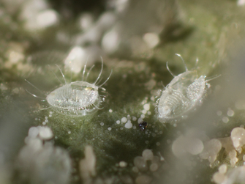

Häutungsreste
(Exuvien)
der
Weißen
Fliege

**Biology**

The
greenhouse
moth
scale
insect
belongs
to
the
moth
scale
insects
(Aleurodina)
a
subgroup
of
plant
suckers.

The
greenhouse
moth
scale
insect
goes
through
several
stages
of
development
until
it
becomes
an
imago.

The
larvae
in
the
first
stage
look
for
a
place
on
the
natal
leaf
to
suck
plant
sap,
which
they
later
do
not
leave.
From
the
second
larval
stage
on,
the
animals
are
attached
to
the
plants.
Using
a
sucking
proboscis
(similar
to
aphids),
they
extract
sugar
sap
from
the
vascular
bundles
of
their
host
plant.
In
many
host
plants
with
tiers
of
leaves,
such
as
cucumbers
or
tomatoes,
the
egg-laying
females
are
found
on
the
upper,
younger
leaves;
the
larvae
are
found
on
the
middle
leaves,
while
the
hatching
whiteflies
are
found
on
the
lower,
older
leaves.

Eggs,
as
well
as
larvae
and
adults,
constantly
require
fresh
plants
for
survival
and
perish
on
wilted
leaves
after
a
short
time.
Symbiotic
microorganisms
(bacteria)
that
produce
vitamins
important
to
the
moth
scale
insect
live
in
the
yellow
spots
inside
the
body.
During
egg
development,
the
bacteria
migrate
from
the
mother
animal
into
the
still
unfinished
eggs
and
are
transferred
in
this
way
to
the
animals
of
the
next
generation.

At
21
°C,
development
from
egg
to
finished
insect
takes
25
to
30
days.
Thus,
numerous,
overlapping
generations
can
develop
in
any
given
year.

In
our
country,
the
whitefly
can
only
overwinter
on
green
plants
in
glass
houses
or
living
rooms,
as
it
has
no
dormant
stage
and
is
also
sensitive
to
cold.

**Damage
symptoms**

Infested
plants
are
usually
damaged
less
by
the
direct
sucking
activity
than
by
sugary
excretions
(honeydew)
of
the
larvae.
Since
the
animals
prefer
to
sit
on
the
undersides
of
leaves,
the
honeydew
drips
onto
the
leaves
and
fruit
below.
Black
fungi
can
then
colonize
this
shiny
coating.
This
so-called
"sooty
mold"
contaminates
the
fruit
on
the
one
hand,
and
on
the
other
hand,
affected
leaves
lose
assimilation
surface,
which
weakens
the
plants.

**Host
plants**

In
addition
to
cucumbers,
tomatoes
and
melanzani,
and
less
frequently
peppers
and
beans,
many
ornamental
plants
and
weeds
are
attacked.

**Distribution**

In
temperate
latitudes
worldwide,
whiteflies
are
restricted
to
greenhouses,
or
at
most
their
surroundings,
since
they
cannot
overwinter
outdoors.
In
warmer
areas,
however,
this
restriction
does
not
apply.

**Propagation
and
transmission**

Greenhouse
moth
scale
can
be
carried
with
a
wide
variety
of
plant
species
(usually
propagules)
in
all
stages
of
development
(eggs,
larvae,
pseudopuparia).

**Economic
importance**

The
greenhouse
moth
scale
has
become
an
economically
important
pest
of
greenhouse
vegetables
and
ornamentals
because,
in
addition
to
direct
sucking
damage,
it
damages
plants
indirectly
as
a
virus
vector
and
it
has
already
developed
resistance
to
insecticides,
making
it
difficult
to
control.

**Prevention
and
control**

* Prevention
  of
  overwintering:
  particular
  danger
  comes
  from
  overwintering
  ornamental
  plants
  (hanging
  baskets
  in
  front
  rooms
  or
  in
  neighboring
  homes).
  Fuchsias,
  gerberas,
  etc.
  are
  often
  particularly
  heavily
  infested.
* Avoidance
  of
  spreading:
  never
  go
  from
  a
  heavily
  infested
  greenhouse
  to
  an
  uninfested
  one.
* Monitoring:
  in
  order
  to
  detect
  the
  initially
  harmless
  infestation
  by
  the
  moth
  scale
  insect
  in
  time,
  glued
  yellow
  boards
  should
  be
  fixed
  just
  above
  the
  plant
  tips.
  The
  yellow
  color
  attracts
  numerous
  pest
  species,
  such
  as
  whitefly,
  fungus
  gnat,
  and
  leaf
  miner.
  However,
  yellow
  panels
  alone
  are
  not
  suitable
  for
  effectively
  controlling
  whiteflies.
* Chemical
  control:
  Sprays
  against
  whitefly(s)
  (moth
  scale
  insects)
  or
  sucking
  insects
  can
  be
  used
  as
  chemical
  control.
  At
  least
  two
  treatments
  are
  necessary,
  about
  five
  to
  seven
  days
  apart.
  The
  whitefly
  tends
  to
  develop
  resistance
  to
  pesticide
  active
  ingredients
  -
  this
  forces
  frequent
  changes
  of
  active
  ingredient
  groups
  (see
  [list
  of
  pesticides
  approved
  in
  Austria](https://www.baes.gv.at/zulassung/pflanzenschutzmittel/pflanzenschutzmittelregister/)).
* Biological
  control:
  By
  releasing
  *Encarsia
  wasps*:
  this
  small
  wasp
  injects
  its
  eggs
  into
  young
  whitefly
  larvae,
  so
  that
  the
  last
  to
  hatch
  is
  a
  whitefly
  instead
  of
  a
  whitefly.
  In
  individual
  cases,
  additional
  selective
  plant
  protection
  products
  that
  are
  gentle
  on
  beneficial
  insects
  may
  have
  to
  be
  applied.
  If
  beneficial
  insects
  are
  used,
  the
  lower
  leaves
  should
  not
  be
  removed
  too
  quickly,
  as
  this
  often
  results
  in
  the
  removal
  of
  wasps
  that
  have
  not
  yet
  hatched.
  Furthermore,
  yellow
  panels
  should
  not
  be
  used,
  as
  the
  wasps
  are
  also
  caught
  by
  the
  yellow
  panels.
* Other
  beneficial
  insects
  that
  can
  be
  used
  are
  the
  ichneumon
  wasp
  *Eretmocerus
  eremicus*
  and
  the
  predatory
  bug
  *Macrolophus
  caliginosus*,
  which
  can
  be
  combined
  well
  with
  *Encarsia*.
  Predatory
  mites
  of
  the
  genus
  *Amblyseius*
  and
  entomopathogenic
  fungi*(Beauveria
  bassiana*)
  can
  also
  be
  used
  to
  reduce
  infestations
  against
  whiteflies.

**Links**

[Information
from
the
EPPO
on
*Trialeurodes
vaporariorum*](https://gd.eppo.int/taxon/TRIAVA)

**Services**

[Plant
Health
Services](en/plant/plant-health/plant-health-information)