Fire blight

07.05.2024 20:41 Uhr

Fire
blight

Erwinia
amylovora
Last
change:
10.10.2023

Profile
Fire
blight
is
a
highly
infectious,
difficult-to-control
disease
of
various
fruit
and
ornamental
trees
of
the
rose
family.
The
pathogen
is
a
bacterium
that
leads
to
a
brownish
to
black
coloration
of
the
affected
plants
and
the
discharge
of
sticky
bacterial
slime.
Affected
plants
can
die
within
a
very
short
time.

Damage
symptoms
Leaves
and
flowers
of
infected
plants
suddenly
wilt
and
turn
brown
or
black.
Infected
shoots
initially
appear
pale
green,
dry
out
and
turn
brown
to
black.
As
a
result
of
water
loss,
the
tips
of
the
shoots
often
bend
downward
in
a
hook
shape.
In
damp
weather,
whitish
drops
of
sticky
bacterial
slime
emerge
from
the
infested
areas,
later
turning
brown.
This
can
also
be
found
under
the
bark
of
freshly
infested
trees,
the
wood
is
usually
reddish
brown
in
color
and
interspersed
with
slime,
which
sometimes
also
breaks
out
of
the
bark.
Towards
the
end
of
the
annual
growing
season,
the
spread
of
the
bacteria
comes
to
a
halt.
Diseased
sections
of
bark
sink
in,
creating
a
distinct
boundary
line
between
diseased
and
healthy
tissue.
During
the
winter,
the
dead
leaves
and
shriveled
fruits
remain
attached
to
the
parts
of
the
twigs
that
look
like
they
have
been
burned.
The
starting
point
for
new
infections
in
spring
are
bacterial
secretions
that
emerge
from
cancerous
infestations
on
the
perennial
wood.
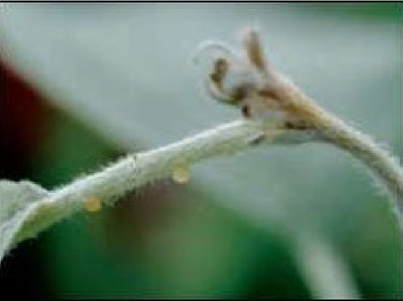
Austretender
Bakterienschleim
an
einem
Trieb
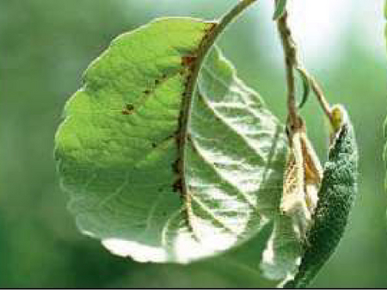
Erste
Symptome
am
Blatt
eines
Apfelbaumes
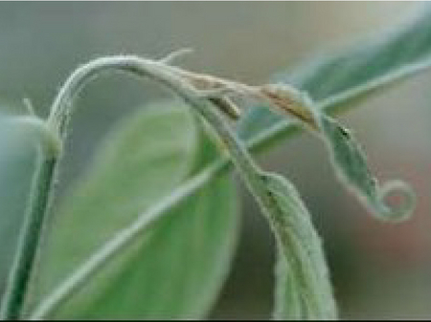
Hakenförmig
gekrümmter
Trieb
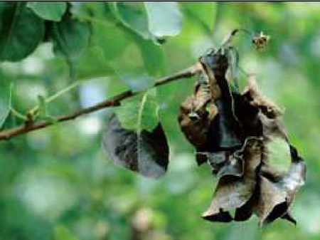
Infizierter
Trieb
ausgehend
von
einer
Büteninfektion
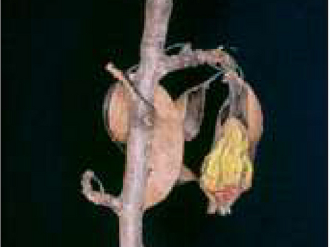
Fruchtmumie
einer
Birne

Host
plants
Fire
blight
attacks
various
fruit
and
ornamental
trees
from
the
botanical
family
Rosaceae
(e.g.
apple).
Post-flowering
and
young
plants
with
late
flowering
are
particularly
at
risk.

Distribution
The
USA
is
considered
to
be
the
country
of
origin
of
fire
blight.
In
Europe,
fire
blight
first
appeared
in
southern
England
and
has
since
been
detected
in
almost
all
European
countries.

Propagation
and
transmission
After
transfer
to
the
shoots
of
susceptible
host
plants,
the
fire
blight
pathogen
penetrates
through
natural
openings
(pores,
stomata)
or
through
wounds.
The
spread
of
the
pathogen
within
a
host
plant
is
much
faster
in
young
shoots
than
in
older
ones.
The
first
signs
of
dieback
may
become
visible
no
earlier
than
four
days
after
infection.
Within
two
to
three
weeks,
a
young
pear
tree
may
be
dead.
Particular
risks
for
the
further
spread
of
the
disease
are
posed
by:
- Rain,
hail,
wind
(causing
small
wounds).
- tools,
shoes,
hands,
clothing,
tires
and
machinery.
To
prevent
the
introduction
or
spread
of
the
disease
with
contaminated
plant
material,
it
is
essential
to
know
if
the
material
comes
from
a
fire
blight-free
area.
Strict
requirements
must
be
followed
when
delivering
fire
blight
host
plants
to
protected
areas.

Economic
importance
Both
commercial
and
landscape-defining
orchards
are
threatened,
as
are
nurseries,
home
gardens,
and
public
green
spaces.

Prevention
and
control
- Reduce
infectious
material
as
far
as
possible
already
before
flowering.
- Regular
inspections
of
leaves,
flowers
and
bark
during
dry
weather
- Avoid
as
far
as
possible
in
case
of
acute
risk
of
infection:
  - Plant
protection
treatments
against
animal
or
fungal
pathogens
  - Over-crown
sprinkling
  - Mechanical
thinning
- Grubbing
up
or
generous
pruning
as
soon
as
possible
(preferably
within
a
few
days
after
fire
blight
infestation
has
been
detected)
- Closure/flaming
of
larger
interfaces
- Immediate
burning
of
uprooted
or
cut
off
infested
plant
parts
(never
leave
open!)
- Avoid
injury
to
healthy
trees
- In
case
of
strong
slime
formation,
postpone
sanitation
- In
case
of
heavy
infestation,
no
mechanical
measures
such
as
shaping
and
pruning
(great
risk
of
spreading
bacteria)
- Always
disinfect
or
flame
cutting
tools
thoroughly!
- For
plant
protection
products
approved
for
the
control
of
fire
blight,
please
refer
to
the
list
of
plant
protection
products
approved
in
Austria.

Phytosanitary
status
Erwinia
amylovora
is
a
Union-regulated
non-quarantine
pest.

Specialized
information
We
carry
out
detection
of
the
fire
blight
pathogen
in
suspected
plants
or
asymptomatic
tissue
and
coordinate
activities
for
strategic
control.
Information
on
the
current
risk
of
infection
can
be
found
at
thewarning
service
of
the
Austrian
Chambers
of
Agriculture
or
at
the
official
plant
protection
services
of
the
federal
states.
At
regular
intervals,
we
hold
the
Fire
Blight
Round
Table,
to
which
all
stakeholders
and
experimenters/scientists
concerned
with
fire
blight
in
Austria
are
invited.
It
serves
as
a
forum
for
the
exchange
of
information
on
all
fire
blight
topics,
for
the
coordination
and
planning
of
various
activities
and
for
the
dissemination
of
current
research
results.

Downloads

Fire
blight
folder
- pdf
Fire
blight
folder
1
MB

Specimen
accompanying
document
- pdf
Fire
blight
sample
submission
form
79
KB

Services
Plant
Health
Services

