|  |  |
| --- | --- |
| Logo AGES | |
| Dry bulb mite | |
|  |  |
| 08.07.2025 14:12 Uhr | |

**Dry
bulb
mite**

**Aceria
tulipae**

Last
change:
10.03.2025

**Profile**

Garlic
gall
mite
is
one
of
the
most
important
pests
in
the
cultivation
of
garlic.
Symptoms
of
damage
are,
in
addition
to
restrictions
in
plant
growth
in
the
field,
discoloration
and
withering
of
the
garlic
cloves
in
storage.
Control
of
the
mites
is
difficult,
as
they
usually
only
become
visible
on
stored
garlic.

**Appearance**

Adults
have
two
pairs
of
legs
on
the
anterior
body,
while
the
posterior
part
of
the
body
is
cylindrical
in
shape
and
shows
external
ringing.
Two
longer,
conspicuous
bristles
are
visible
at
the
end
of
the
body.
Because
these
mites
are
very
brightly
colored
and
only
0.3
mm
long,
they
are
not
visible
to
the
naked
eye
-
a
magnifying
glass
or
microscope
is
required
to
observe
them.
They
are
most
easily
identified
by
the
symptoms
of
damage.
However,
the
exact
identification
can
only
be
done
by
a
specialist:
for
this
purpose,
features
of
the
body
surface,
such
as
position
of
the
bristles
are
important,
as
well
as
a
so-called
feather
bristle
on
the
front
legs.

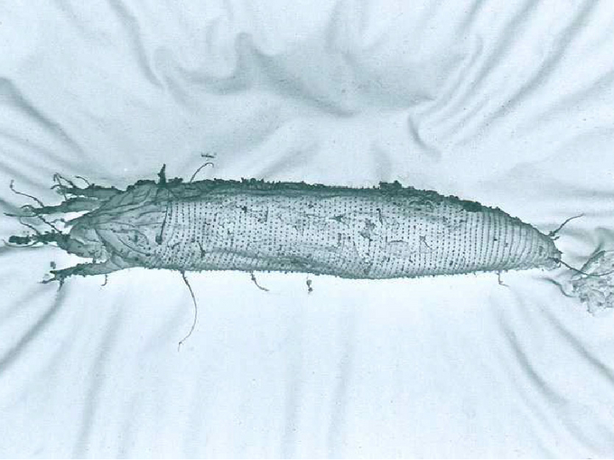

Knoblauchmilbe
in
einer
rasterelektronenmikroskopischen
Aufnahme

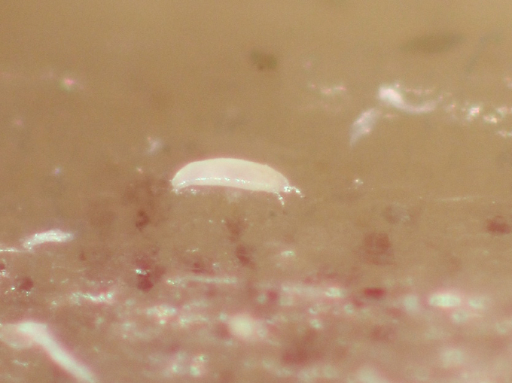

Stereomikroskopische
Aufnahme
einer
Knoblauchgallmilbe
(ca.
0,3
mm
lang)

**Biology**

The
garlic
gall
mite
-
also
called
the
tulip
gall
mite
-
belongs
to
the
gall
or
curly
mites
(Eriophyidae),
a
family
within
the
large
group
of
mites.
Despite
its
name,
however,
this
species
does
not
produce
galls.
During
the
growing
season,
the
mites
live
on
green
plant
parts
of
garlic
and
other
lily
plants.
They
prefer
young
tissue,
especially
stomata
of
not
yet
unfolded
leaves
and
inflorescences.
From
the
inflorescences,
they
can
then
very
easily
migrate
to
brood
bulbs.

The
mites
can
develop
optimally
at
a
temperature
of
25°C
and
a
relative
humidity
of
80-95%.
Each
female
lays
about
25
eggs,
from
which
larvae
hatch
after
a
short
time.
The
incubation
period
is
two
days
at
25
°C
and
about
one
month
at
2
°C.
The
mites
pass
through
two
larval
stages
in
their
development.
To
feed,
they
superficially
bite
the
tissue
of
the
garlic
plant
with
their
very
short,
pincer-like
mouthparts.
Only
in
very
severe
infestations
are
symptoms
of
damage
seen
on
the
leaves,
which
twist
in
easily
and
stick
to
each
other
as
they
unfurl.

When
the
garlic
is
pulled
in,
they
attach
themselves
both
to
air
bulbs
but
also
to
the
"ground
cloves",
where
they
are
very
well
protected
between
the
garlic
clove
and
the
sheathing
leaf
surrounding
it.
If
the
temperature
is
high
enough,
they
can
multiply
well
here
and
are
often
found
in
the
small
dimple
below
the
tip
of
the
clove.
Low
infestation
is
practically
undetectable,
so
it
can
easily
happen
that
slightly
infested
toes
are
stored
for
harvesting.
However,
if
stored
too
warm
(summer
temperatures,
not
refrigerated),
the
mites
multiply
rapidly,
so
that
the
toes
dry
out
easily
as
a
result
of
punctures.

On
heavily
infested
inflorescences
in
the
field,
flower
bugs*(Orius
species*)
and
predatory
mites
from
the
family
Tydeidae
were
found
as
natural
enemies.
It
is
likely
that
garlic
gall
mites
can
overwinter
in
our
field
-
in
any
case,
the
animals
withstood
great
cold
of
-24
°C
well
in
laboratory
tests.

**Damage
symptoms**

The
sucking
activity
of
the
garlic
gall
mites
causes
yellowing
and
twisting
of
the
leaves.
Younger
leaves
get
stuck
due
to
the
lack
of
development
of
older
leaves.
Heavily
infested
air
bulbs
lag
behind
in
growth,
so
that
the
size
of
the
air
bulbs
varies
greatly.

Heavily
infested
garlic
cloves
in
storage
can
be
recognised
by
the
fact
that
they
become
very
light
as
a
result
of
drying
out.
They
are
easy
to
squeeze
and
have
a
yellowish-brown
colour
when
peeled.

In
addition,
the
sucking
activity
can
lead
to
the
transmission
of
allexiviruses
such
as
Garlic
virus
A
to
Garlic
virus
E
and
Garlic
virus
X.

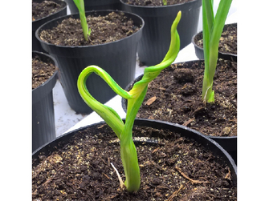

Symptom
der
Blattverdrehung
und
mangelnde
Blattentfaltung
bei
Befall
durch
Knoblauchgallmilben

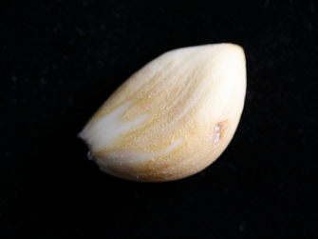

Verfärbung
der
Knoblauchzehe

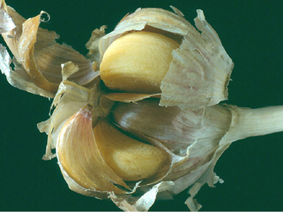

Stark
befallene
Knoblauchzehen

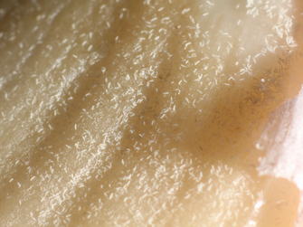

Massenhaftes
Auftreten
der
Knoblauchgallmilbe

**Host
plants**

The
garlic
gall
mite
not
only
attacks
garlic,
but
also
other
allium
plants
of
the
genus
Allium
(onion,
shallot,
leek,
chives)
and
lily
plants,
such
as
tulips.
However,
the
mention
of
its
occurrence
on
cereals
in
connection
with
the
streak
virus
is
based
on
a
misidentification.

**Distribution**

The
garlic
gall
mite
can
be
found
on
all
continents
(Africa,
Asia,
Europe,
North
America,
Oceania,
South
America)
except
Antarctica.

**Propagation
and
transmission**

Garlic
gall
mites
are
transmitted
during
the
cultivation
of
garlic
with
infested
seeds.
The
garlic
gall
mite
behaves
like
a
storage
pest
in
storage.
The
infestation
starts
from
slightly
infested
garlic
cloves
or
air
bulbs
and
is
very
easily
overlooked.

**Economic
importance**

Despite
its
tiny
size,
the
garlic
gall
mite
is
one
of
the
most
important
pests
in
the
cultivation
of
garlic
in
agriculture.
This
is
because
it
usually
multiplies
unnoticed
in
the
store,
can
cause
massive
damage
through
its
sucking
activity
on
the
cloves
and
control
is
no
longer
possible
at
this
stage.

**Prevention
and
control**

* Use
  healthy
  planting
  material.
  Under
  no
  circumstances
  should
  untested
  consumer
  goods
  be
  used,
  as
  these
  are
  sometimes
  infested.
* In
  the
  case
  of
  self-propagation
  via
  air
  bulbs,
  the
  inflorescences
  should
  not
  be
  left
  on
  the
  plant
  until
  the
  bracts
  open,
  as
  the
  mites
  can
  easily
  migrate
  into
  flowers
  and
  thus
  onto
  air
  bulbs.
* The
  crop
  should
  be
  stored
  in
  a
  cool,
  dry
  place
  to
  prevent
  any
  mites
  that
  may
  be
  present
  from
  multiplying.
  The
  individual
  batches
  of
  garlic
  should
  be
  stored
  at
  a
  certain
  distance
  from
  each
  other
  so
  that
  no
  migration
  from
  infested
  to
  healthy
  cloves
  can
  take
  place.
* As
  a
  chemical
  control
  method
  for
  plant
  protection,
  the
  literature
  mentions
  treatment
  with
  sulfur
  dust
  in
  storage
  and
  fumigation
  of
  the
  crop
  in
  tightly
  closed
  rooms
  by
  licensed
  companies.

**Specialized
information**

**Publications**

Moyses,
A.,
2016.
the
garlic
gall
mite
(Aceria
tulipae):
a
hidden
pest
of
garlic.
Vegetable
Crop
Practice,
23(1),
16-17.

**Investigations**

To
ensure
that
garlic
growers
can
continue
to
have
confidence
in
the
health
of
their
seedlings,
garlic
seedling
surveys
are
essential
to
ensure
freedom
from
infestation
by
garlic
gall
mites
throughout
the
growing
season
and
into
storage.

At
the
Sustainable
Cropping
Department,
we
conduct
testing
of
harvested
or
planted
material
for
*Aceria
tulipae*.

**Links**

[Warning
service
of
the
Chambers
of
Agriculture](https://warndienst.lko.at/)

**Services**

[Plant
Health
Services](en/plant/plant-health/plant-health-information)