|  |  |
| --- | --- |
| Logo AGES | |
| Downy mildew on poppy | |
|  |  |
| 04.07.2025 08:24 Uhr | |

**Downy
mildew
on
poppy**

**Peronospora
arborescens**

Last
change:
23.11.2021

**Profile**

Downy
mildew
on
winter
poppy
is
caused
by
the
pathogen
*Peronospora
arborescens*.
Downy
mildew
fungi
(Peronosporaceae)
belong
to
the
class
of
egg
fungi,
which
are
also
known
as
oomycetes.
Drippable
water,
such
as
dew,
is
essential
for
the
life
cycle
of
egg
fungi.

**Damage
symptoms**

The
first
symptoms
of
downy
mildew
are
yellowish
brightenings
on
the
tops
of
the
leaves,
sometimes
the
entire
plant
is
discolored
yellow.
These
spots
are
between
0.5
and
4
cm
in
size.
The
infected
tissues
are
often
curled,
bulging
or
thickened.
Infected
young
plants
are
conspicuous
in
stands
by
their
pale
or
already
yellowish-white
leaves.
They
are
retarded
in
growth
and
may
also
die
completely.
Infested
flower
stalks
turn
inwards,
the
buds
or
sepals
can
also
be
infested
and
the
plants
subsequently
die.
If
the
capsules
are
infested,
the
seeds
are
also
infected.
The
typical,
initially
whitish,
later
grayish-purple
sporangia
can
be
seen
on
all
infested
plant
parts,
especially
in
humid
weather.

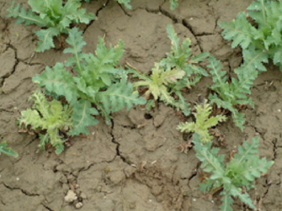

Befall
an
Jungpflanzen

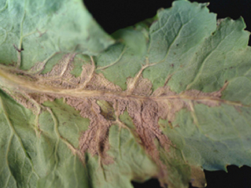

Sporangienrasen
auf
der
Blattunterseite

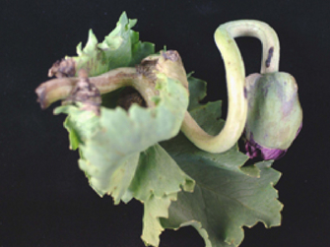

Befall
an
Blütenstängel

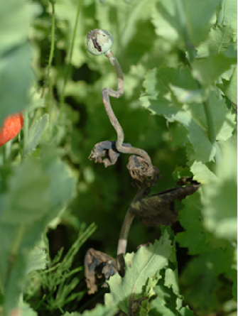

Befall
an
ausreifender
Pflanze

**Host
plants**

In
addition
to
*Papaver
somniferum*,
*Papaver
alpinum*,
*P.
dubium*,
P.
*caucasicum*,
P.
*nudicaule*,
P.
*rhoeas*,
*P.
setigerum*,
and
*Mecomopsis*
spp.
are
also
infested.

**Distribution**

*Peronospora
arborescens*
is
widely
distributed
in
Algeria,
Egypt,
Afghanistan,
Azerbaijan,
India,
Iraq,
Japan,
Turkey,
Pakistan,
Australia,
Argentina,
and
Europe.

**Propagation
and
transmission**

Spread
occurs
through
infected
seeds.
Furthermore,
the
pathogen
forms
sporangia
carriers
with
sporangia,
which
release
mobile
spores
(zoospores).
The
sporangia
usually
grow
on
the
undersides
of
the
leaves
from
the
stomata
or
other
openings
in
the
plant.
The
sporangia
are
spread
by
wind
or
rain.
The
zoospores
require
dripping
water
to
travel
and
germinate.
After
germination,
they
penetrate
directly
into
the
plant
tissue.

To
survive,
the
pathogen
forms
robust
spores
(oospores).
They
are
spherical
and
dark
brown
in
color,
but
not
visible
to
the
naked
eye.
Oospores
can
survive
in
the
soil
for
several
months.

**Economic
importance**

In
damp
and
cool
weather,
downy
mildew
is
likely
to
occur
on
winter
poppies.
Between
10
and
20
%
of
the
young
plants
can
be
infested.
Reduced
yields
are
the
result.

**Prevention
and
control**

* Adherence
  to
  a
  crop
  rotation
  of
  at
  least
  three
  years
* Use
  of
  healthy
  seeds
* In
  case
  of
  heavy
  infestation,
  use
  of
  approved
  plant
  protection
  products
  (see
  [list
  of
  plant
  protection
  products
  approved
  in
  Austria](https://www.baes.gv.at/zulassung/pflanzenschutzmittel/pflanzenschutzmittelregister/))

**Services**

[Plant
Health
Services](en/plant/plant-health/plant-health-information)