|  |  |
| --- | --- |
| Logo AGES | |
| Downy mildew of sunflower | |
|  |  |
| 08.07.2025 12:18 Uhr | |

**Downy
mildew
of
sunflower**

**Plasmopara
halstedii**

Last
change:
25.05.2023

**Profile**

Downy
mildew
of
sunflower
is
caused
by
the
pathogen
*Plasmopara
halstedii*
.
Downy
mildew
fungi
(Peronosporaceae)
belong
to
the
class
of
egg
fungi,
which
are
also
known
as
oomycetes.
Drippable
water,
such
as
dew,
is
essential
for
the
life
cycle
of
egg
fungi.
*Plasmopara
halstedii*
is
listed
as
a
[Union
regulated
non-quarantine
pest](https://www.pflanzenschutzdienst.at/geregelte-schaedlinge/).

**Damage
symptoms**

On
young
plants,
irregular,
light
green
to
yellow
brightenings
develop
along
the
leaf
veins
on
the
upper
side.
A
white,
felt-like
coating
(=
sporangia
carrier
with
sporangia)
is
formed
on
the
underside
of
the
leaf.
Affected
plants
are
retarded
in
growth
and
are
compressed.
The
stem
grows
more
slowly,
is
thus
shortened
and
thickened,
and
the
leaves
are
subsequently
more
densely
packed
together.
In
severe
infestations,
the
leaves
are
curled.
Under
humid
weather
conditions,
the
white
coating
can
also
be
formed
on
the
upper
side
of
the
leaves.
Early
infestation
often
leads
to
the
death
of
infected
seedlings
or
young
plants.
If
the
pathogen
attacks
the
plants
in
the
flowering
stage,
it
usually
forms
the
white
sporangial
turf
on
both
sides
of
the
leaves
on
the
highest-lying
leaves.

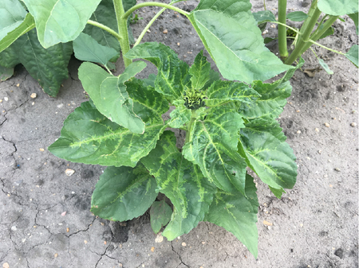

Befallene
Sonnenblumenpflanze

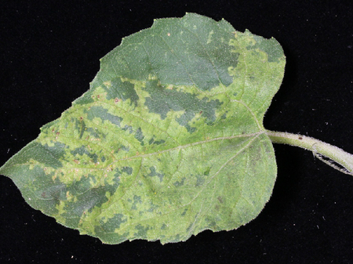

Symptome
an
der
Blattoberseite

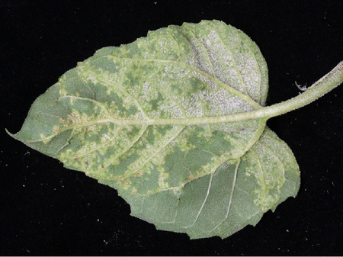

Symptome
an
der
Blattunterseite

**Host
plants**

The
main
host
plants
are
*Helianthus
annuus*,
*Helianthus
tuberosus*,
*Xanthium
strumarium*,
*Artemisia
dracunculus*,
*Ambrosia
artemisiifolia*
and
*Iva
xanthifolia*.

In
addition,
more
than
100
species
from
the
composite
family
(Asteraceae)
are
other
host
plants,
including
aster,
goldmaria*(Bidens*),
occupational
herb
(*Erigeron*),
watercress
(*Eupatorium*),
coneflower
(*Rudbeckia*),
silphia
(*Silphium*),
and
goldenrod*(Solidago*).

**Distribution**

The
pathogen
is
widespread
in
sunflower-producing
countries
worldwide.

**Propagation
and
transmission**

*Plasmopara
halstedii*
is
mainly
seed-borne,
but
infected
plant
debris
in
the
soil,
susceptible
weeds
of
the
composite
family
(Asteraceae),
and
volunteer
sunflowers
also
serve
as
sources
of
infection.

Downy
mildew
forms
sporangial
carriers
with
sporangia
that
release
motile
spores
(zoospores).
These
zoospores
require
drippable
water
to
travel
and
germinate.
After
germination,
they
penetrate
directly
into
the
plant
tissue.
After
successful
infection,
the
pathogen
grows
intercellularly
and
colonizes
the
host
plant
systemically.
As
the
disease
progresses,
sporangia
are
formed
again.
The
sporangia
usually
grow
on
the
undersides
of
the
leaves
from
the
stomata
or
other
openings
in
the
plant.
The
sporangia
are
spread
by
wind
or
rain.

The
pathogen
survives
by
means
of
permanent
spores
and/or
mycelium
in
the
infected
plant
tissue
of
its
host
plants.

**Economic
importance**

The
majority
of
infected
plants
die
before
they
reach
seed
maturity
or
produce
only
isolated
viable
seeds.
Yield
reductions
also
result
from
the
death
of
infected
seedlings.
Yield
reductions
of
up
to
50%
are
possible,
in
exceptional
cases
even
up
to
95%.

**Prevention
and
control**

* Adherence
  to
  the
  widest
  possible
  crop
  rotation
* Use
  of
  healthy
  seeds
* Fast
  rotting
  of
  plant
  residues

**Phytosanitary
status**

*Plasmopara
halstedii*
is
listed
as
a
[Union
regulated
non-quarantine
pest](https://www.pflanzenschutzdienst.at/geregelte-schaedlinge/)
and
is
transmitted
through
certain
planting
material.
The
presence
of
such
pests
leads
to
unacceptable
economic
consequences
with
regard
to
the
intended
marketing
of
the
planting
material.
The
import
and
movement
within
the
EU
are
therefore
uniformly
regulated
for
specific
seed
and
planting
material.

**Links**

[Information
from
the
EPPO
on
*Plasmapara
halstedii*](https://gd.eppo.int/taxon/PLASHA/documents)

**Services**

[Plant
Health
Services](en/plant/plant-health/plant-health-information)