|  |  |
| --- | --- |
| Logo AGES | |
| Covered smut of barley | |
|  |  |
| 15.08.2025 13:18 Uhr | |

**Covered
smut
of
barley**

**Ustilago
hordei**

Last
change:
10.04.2025

**Profile**

Barley
hard
blight
is
a
fungal
disease
that
exclusively
affects
barley
plants.
The
spore
deposits
on
the
ear
are
covered
by
a
dull,
silver-gray
membrane
and
harden
until
harvest.

**Damage
symptoms**

The
spore
deposits
on
the
ear
are
covered
for
a
long
time
by
a
dull,
silver-gray
membrane.
The
spore
deposits
harden
until
harvest
and
are
not
or
only
incompletely
dusted
out.
The
awns
are
often
deformed,
but
often
remain
intact.

The
symptoms
of
barley
hard
blight
are
similar
to
those
of
barley
fly
blight.

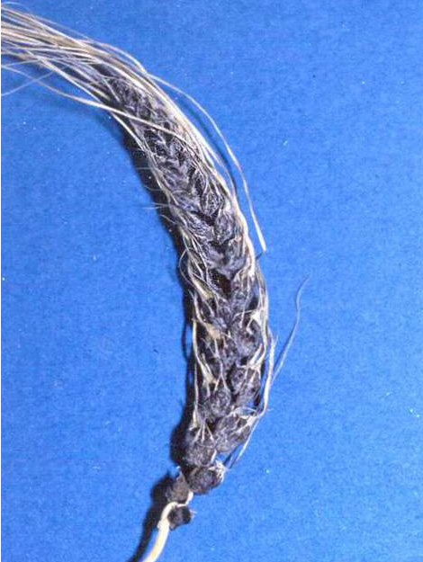

Eine
mit
Gerstenhartbrand
befallene
Ähre

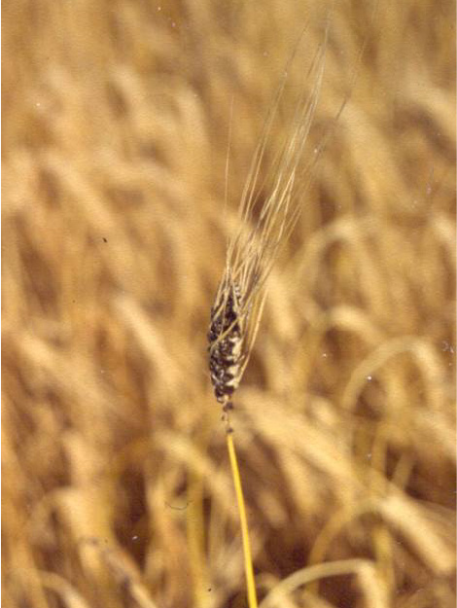

Eine
mit
Gerstenhartbrand
befallene
Ähre
in
einem
abgetrockneten
Gerstenbestand

**Host
plants**

The
causal
agent
of
barley
hard
blight
attacks
only
barley
plants.

**Distribution**

Barley
hard
blight
can
occur
in
all
growing
regions.

**Propagation
and
transmission**

The
fungus
is
spread
to
healthy
soils
by
using
infected
seeds.
Infection
of
the
seedling
occurs
through
spores
on
the
seed.
However,
in
addition
to
seed-borne
infection,
transmission
from
the
soil
is
also
possible.

**Economic
importance**

Yield
losses
are
to
be
expected
in
case
of
severe
infestation
with
barley
hard
blight.

**Prevention
and
control**

* Use
  of
  tested
  and
  healthy
  seed
  is
  recommended
* Seed
  dressing
  against
  the
  pathogen
  *Ustilago
  hordei*
  is
  possible
* Keeping
  wide
  crop
  rotations
  are
  recommended

**Services**

[Plant
Health
Services](en/plant/plant-health/plant-health-information)