|  |  |
| --- | --- |
| Logo AGES | |
| Common milkweed | |
|  |  |
| 04.07.2025 16:41 Uhr | |

**Common
milkweed**

**Asclepias
syriaca**

Last
change:
10.09.2024

**Profile**

The
common
milkweed
is
a
poisonous
plant
and
originates
from
North
America.
It
was
introduced
and
cultivated
in
Europe
as
a
garden
and
ornamental
plant,
fiber
plant
and
bee
pasture.
The
species
is
on
the
list
of
invasive
alien
species
of
Union
importance.

**Appearance**

The
plant
is
perennial,
lactiferous
and
grows
up
to
150
cm
tall.
The
leaves
are
derb-leaved,
opposite,
with
white
felt-like
hairs
on
the
underside
and
up
to
15-20
cm
long.
The
brown-red
and
long-stalked
flowers
appear
in
many-flowered
umbels.
Flowering
begins
in
early/mid-June
under
local
conditions,
and
the
plant
produces
soft-thorned,
horn-shaped
fruits
about
10-15
cm
long
(hence
the
name
"parrot
fruit").
The
brown
seeds
are
6-10
mm
long
and
have
a
characteristic
silky
mop
of
hair.
The
common
milkweed
is
poisonous.

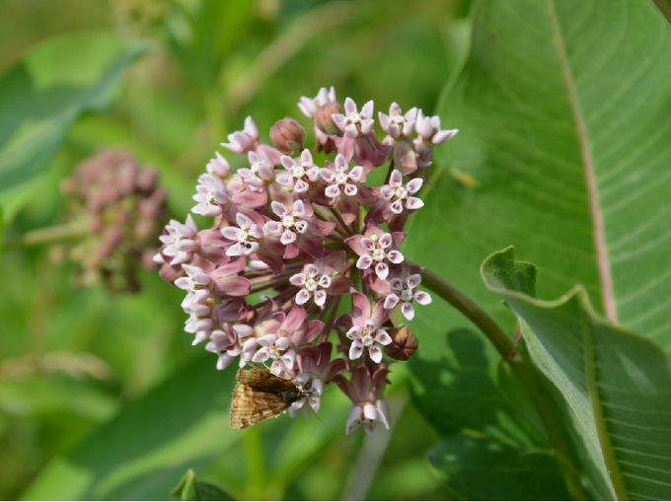

Gewöhnliche
Seidenpflanze
in
der
Blüte

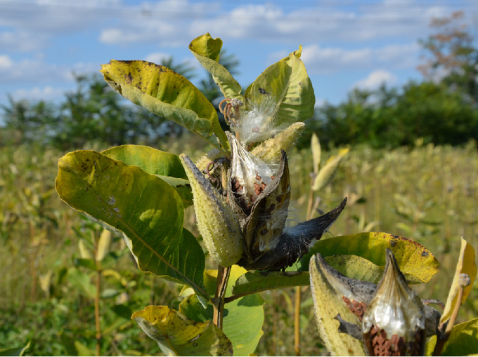

Aufgeplatzte
Früchte
der
Gewöhnliche
Seidenpflanze

**Distribution**

The
original
range
of
the
common
milkweed
includes
large
parts
of
Canada
and
the
USA.
In
Austria,
the
occurrences
of
the
common
milkweed
have
increased
significantly
since
2005
and
a
further
spread
is
likely.
Currently,
the
species
occurs
especially
in
eastern
Austria
(Vienna,
Lower
Austria)
and
only
sparsely
in
western
and
southern
Austria.

**Spread**

The
plant
was
cultivated
as
an
ornamental
plant
and
bee
pasture,
in
the
vicinity
of
gardens
repeatedly
ran
wild.
The
common
milkweed
prefers
to
colonize
sunny
and
dry
soils.
Therefore,
the
species
grows
mainly
on
wastelands
such
as
industrial
wastelands,
railroads,
roadsides
and
pathsides,
but
also
in
agricultural
areas.
Spread
of
the
common
milkweed
also
occurs
naturally
via
its
silky-haired
seeds,
which
are
dispersed
by
wind
in
the
fall.
A
reproductive
shoot
may
produce
two
to
three
fruits,
each
containing
200
or
more
seeds.
However,
the
species
spreads
under
local
conditions
mainly
vegetatively
by
means
of
its
rhizomes.
Sections
of
the
rhizomes
can
be
carried
away
with
soil
material
(e.g.
during
road
construction).

**Economic
importance**

Common
milkweed
occurs
as
a
weed
in
agriculture.
Its
growth
rates
are
an
important
factor
in
its
high
competitive
power
and
yield
losses
are
possible.
It
mainly
affects
crops
such
as
corn,
soybean
and
cereals,
but
also
vegetable
crops.
Due
to
its
rapid
spread
and
robustness,
the
species
invades
semi-natural
areas
(open
forests,
grasslands),
but
also
habitats
worthy
of
protection
(including
dry
grassland
sites)
and
can
form
very
dense
stands.

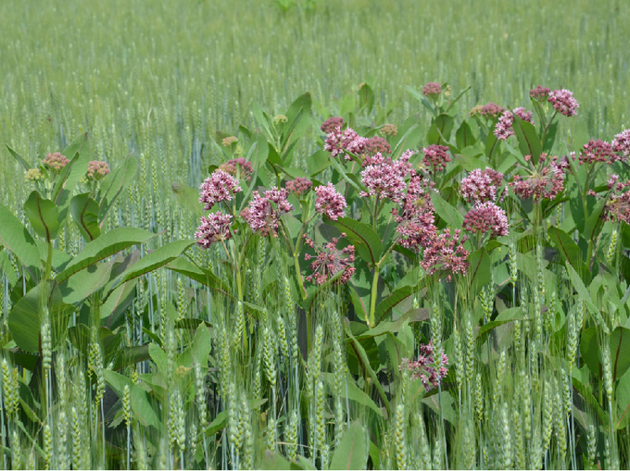

Die
Gewöhnliche
Seidenpflanze
in
Getreide

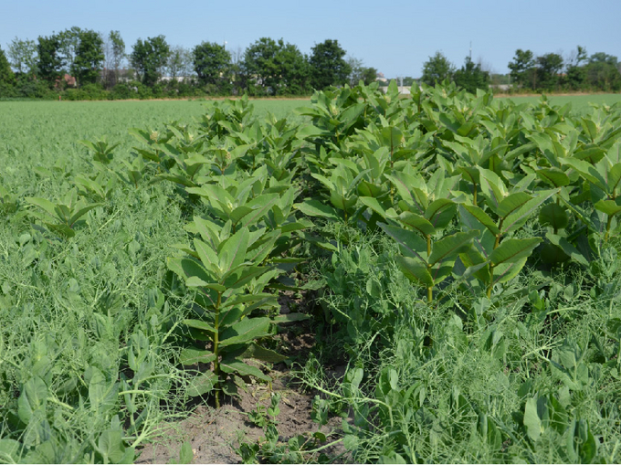

Die
Gewöhnliche
Seidenpflanze
in
Erbse

**Prevention
and
control**

Individuals
and
populations
can
be
removed
manually
using
appropriate
equipment.
However,
the
entire
rootstock
must
be
removed.
Regular
mowing
can
push
back
the
common
milkweed.
Basically,
the
species
can
quickly
regenerate
from
mechanical
injuries.
In
agriculture,
common
milkweed
is
encouraged
by
reduced
tillage
and
the
simultaneous
use
of
herbicides
with
an
insufficient
effect.
The
plant
is
considered
relatively
insensitive
to
a
wide
range
of
herbicides
and
the
effect
is
highly
dependent
on
timing
of
treatment.
Growth
herbicides
usually
cause
only
superficial
damage
to
the
plant.
Established
populations
of
common
milkweed
can
best
be
controlled
with
glyphosate,
according
to
the
literature.
See
also
the
[list
of
plant
protection
products
approved
in
Austria](https://www.baes.gv.at/zulassung/pflanzenschutzmittel/pflanzenschutzmittelregister/).

**Phytosanitary
status**

The
species
is
on
the
list
of
invasive
alien
species
of
Union-wide
importance.

**Specialized
information**

Follak,
S.,
Bakacsy,
L.,
Essl,
F.,
Hochfellner,
L.,
Lapin,
K.,
Schwarz,
M.,
Tokarska-Guzik,
B.,
Wołkowycki,
D.,
2021.
monograph
of
invasive
plants
in
Europe
N°6:
Asclepias
syriaca
L.,
Botany
Letters.
[DOI:
10.1080/23818107.2021.1886984](https://doi.org/10.1080/23818107.2021.1886984)

Follak,
S.,
2018.
the
common
milkweed
-
(not)
a
problem
weed.
The
Plant
Doctor
71(11-12),
18-19.

Follak,
S.,
Schleicher,
C.,
Schwarz,
M.,
2018.
[roads
support
the
spread
of
invasive
Asclepias
syriaca
in
Austria](https://sciendo.com/article/10.2478/boku-2018-0022).
Die
Bodenkultur:
Journal
for
Land
Management,
Food
and
Environment
69,
257-265.

**Services**

[Plant
Health
Services](en/plant/plant-health/plant-health-information)