Citrus long-horned beetle

07.05.2024 23:28 Uhr

Citrus
long-horned
beetle

Anoplophora
chinensis
Last
change:
25.05.2023

Profile
The
name
citrus
longhorned
beetle
is
misleading
because,
although
it
primarily
attacks
citrus
trees
in
its
native
Asia,
it
also
causes
considerable
damage
to
numerous
other
deciduous
trees.
In
the
European
Community,
the
citrus
longhorned
beetle
is
listed
as
a
quarantine
pest
and
is
therefore
notifiable.

Appearance
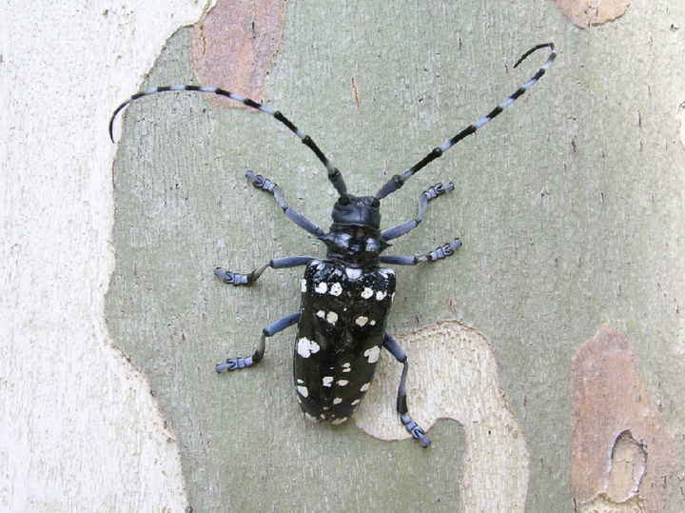
Erwachsener
Zitrusbockkäfer,
©
Matteo
Maspero
The
citrus
longhorn
beetle,
a
member
of
the
longhorn
beetle
family
(Cerambycidae),
is
very
conspicuous
and
hard
to
confuse
in
appearance
with
other
native
longhorn
beetle
species.
It
is
2-4
cm
long,
shiny
black
with
irregular
light
spots
on
the
elytra
and
has
long,
blue-white
ringed
antennae.
The
elytra
base
is
granular.
Males
are
usually
smaller
than
females
and
have
longer
antennae
that
extend
beyond
the
posterior
end
(elytra).
The
cream-colored
larvae
have
an
elongated,
cylindrical
body
and
are
legless.
After
hatching,
they
are
about
5
mm
long
and
grow
up
to
50-60
mm
in
size
as
they
develop.
The
eggs
are
about
5-6
mm
long
and
creamy
white,
yellow-brown
just
before
larval
hatching.
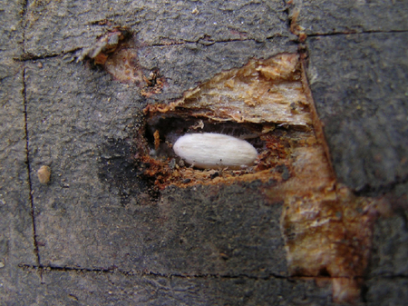
Ei
des
Zitrusbockkäfers,
©
Matteo
Maspero
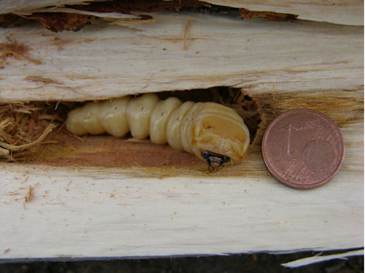
Larve
des
Zitrusbockkäfers,
©
Matteo
Maspero
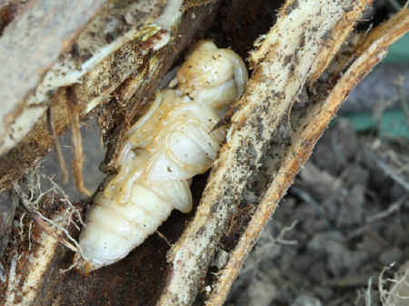
Puppe
des
Zitrusbockkäfers,
©
Matteo
Maspero

Biology
In
Asia,
the
beetles
hatch
from
May
to
about
October
(with
a
focus
in
May
to
July),
in
Central
Europe
from
about
June
to
August.
The
females
begin
laying
eggs
ten
days
after
hatching.
To
do
this,
they
cut
T-shaped
slits
in
the
bark
of
above-ground
roots
or
the
base
of
the
trunk
with
their
mouthparts.
A
female
lays
an
average
of
up
to
70
eggs
individually
in
her
lifetime.
After
about
one
to
three
weeks,
the
larva
hatches
and
feeds
first
in
the
trunk
under
the
bark
(cambial
region).
Later,
the
larval
ducts
spread
into
the
woody
tissue
(sapwood
and
heartwood)
of
the
lowest
parts
of
the
trunk
and
roots.
The
larvae
then
already
reach
a
size
of
5
-
6
cm.
Hibernation
takes
place
in
the
larval
stage
and
pupation
then
in
spring.
The
pupal
stage
lasts
about
four
to
six
weeks,
after
which
the
beetle
hatches
through
circular
bores
(about
1
-
1.5
cm
in
diameter)
at
the
base
of
the
trunk
and
on
above-ground
roots.
Maturing
adult
feeding
occurs
on
leaves,
petioles,
and
the
bark
of
young
twigs.
The
development
cycle
of
the
citrus
longhorned
beetle
usually
lasts
one
year.
However,
depending
on
climatic
conditions,
the
cycle
can
be
as
long
as
two
years,
such
as
in
Central
Europe.

Damage
symptoms
Infested
trees
are
very
difficult
to
detect
due
to
the
hidden
lifestyle
of
the
larvae.
The
first
signs
of
infestation
are
often
drilling
chips
at
the
base
of
the
trunk
and
in
the
root
area,
which
are
caused
by
the
feeding
activity
of
the
larvae.
The
circular,
approx.
1
cm
large
boring
holes
of
the
hatched
beetles
are
also
signs
of
an
infestation
with
the
citrus
longhorned
beetle.
Other
indications
of
an
occurrence
are
finding
the
conspicuous
beetles
themselves
and
the
feeding
marks
of
the
citrus
longhorned
beetles
on
leaves
and
twigs
(maturity
feeding).
The
ripening
feeding
of
the
beetles
additionally
leads
to
wilting
symptoms.
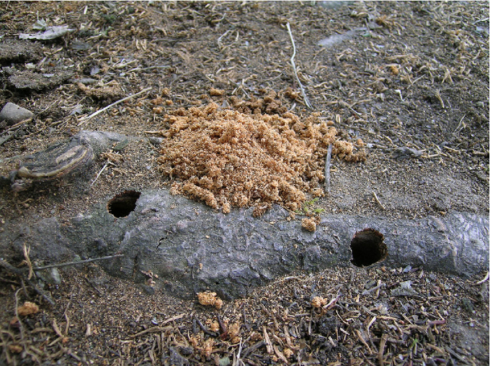
Sägemehl
aus
dem
Bohrloch,
©
Matteo
Maspero
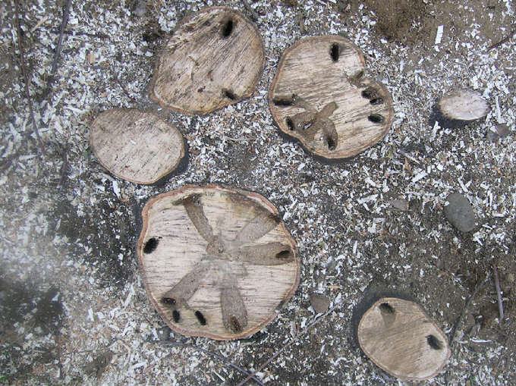
Fraßgänge
der
Larve
mit
Sekundärinfektionen
im
Holz,
©
Matteo
Maspero

Host
plants
The
citrus
longhorned
beetle
can
use
plants
of
more
than
20
families
as
host
plants;
in
its
native
Asia,
citrus
plants(Citrus
spp.)
are
preferred.
However,
the
possible
host
plant
range
includes
numerous
deciduous
woody
plants,
including
fruit
and
ornamental
woody
plants.
In
Asia,
the
host
plant
range
is
wider;
here,
conifers
of
the
genera
Cryptomeria
spp.
and
Pinus
spp.
are
also
included.
Common
host
plants
are:
Maple(Acer
spp.),
Apple
(Malus
spp.),
Pear
(Pyrus
spp.),
Birch
(Betula
spp.),
Beech
(Fagus
spp.),
Alder(Alnus
spp.),
Hornbeam
(Carpinus),
Dogwood
(Cornus
spp.),
Hazelnut(Corylus
spp.),
Curly
Myrtle
(Lagerstroemia
spp.),
Poplar
(Populus
spp.),
sycamore(Platanus
spp.),
rose
(Rosa
spp.),
elm
(Ulmus
spp.),
willow(Salix
spp.),
white-flowered
horse
chestnut(Aesculus
hippocastanum),
hawthorn
(Crataegus
spp.),
citrus
(Citrus
spp.),
dwarf
loquat
(Cotoneaster
spp.),
plum
and
cherry(Prunus
spp.).

Distribution
Originally,
the
citrus
longhorn
beetle
originates
from
East
Asia
(China,
Japan,
Korea)
occasionally
it
also
occurs
in
Malaysia,
Myanmar,
Philippines,
Sumatra,
Taiwan
and
Vietnam.
About
20
years
ago,
there
were
the
first
introductions
to
North
America
and
Europe
(in
2000
for
the
1st
time
in
Italy),
of
which
some
outbreaks
were
eradicated.
Detailed
information
can
be
found
in
the
EPPO
Global
Database.

Propagation
and
transmission
The
greatest
risk
of
spread
or
introduction
of
the
citrus
longhorned
beetle
is
the
trade
of
plants
for
planting.
Especially
in
imported
maple
trees
and
bonsais,
e.g.
fan
maple(Acer
palmatum),
beetle
larvae,
eggs
and
pupae
may
already
be
present
unnoticed.
However,
citrus
longhorned
beetles
can
also
be
unintentionally
introduced
with
wooden
shipping
crates
and
containers
and
wooden
pallets.
The
natural
distribution
of
the
beetles
seems
to
be
rather
very
localized
to
short
distances
(less
than
400
m,
usually
to
the
neighboring
tree)
and
is
rarely
further
than
about
2.5
km.
Environmental
factors,
such
as
climatic
conditions,
host
plant
availability,
and
beetle
population
density,
are
the
most
important
factors
influencing
dispersal
behavior.

Economic
importance
The
massive
damage
is
caused
by
the
feeding
tunnels
of
the
larvae
in
the
trees.
They
go
deep
into
the
wood
and
on
the
one
hand
reduce
the
stability
of
the
trees
(hollowing
of
the
base
of
the
trunk),
on
the
other
hand
they
interrupt
the
sap
and
nutrient
transport,
and
the
tree
dies
as
a
result.
The
holes
drilled
by
the
pest
are
also
ideal
entry
points
for
wood-decomposing
fungi.

Prevention
and
control
As
an
immigrant
in
Europe,
the
citrus
longhorned
beetle
has
practically
no
natural
enemies,
which
is
why
early
detection
through
targeted
controls
is
very
important
for
successful
control.
However,
due
to
their
predominantly
hidden
lifestyle,
both
detection
and
control
of
the
beetles
is
very
difficult.
Preventive
measures
- Targeted
visual
and
mechanical
(destructive)
inspections
for
beetles,
larvae,
boring
dust,
boring
holes
and
traces
of
maturing
beetle
feeding
- Use
of
sniffer
dogs
for
a
more
effective
and
non-destructive
measure
to
detect
citrus
longhorned
beetles
before
they
spread
into
the
field.
Sniffer
dogs
trained
for
this
purpose
can
sniff
out
the
developmental
stages
of
longhorned
beetles
hidden
in
the
wood
and
roots.
- Use
of
specific
attractants
(pheromones);
but
traps
are
not
yet
sufficiently
efficient.
Control
measures
- Clearing
of
infested
trees
is
currently
the
only
effective
measure
to
destroy
larval
and
pupal
stages
of
the
beetles
and
to
deprive
the
adult
beetles
of
their
food
and
development
basis.
- Biological
control
methods
using
entomopathogenic
fungi,
nematodes
or
parasitic
insects
are
still
in
the
experimental
stage.
- Chemical
control:
in
Austria
there
is
no
possibility
of
control
with
chemical
pesticides,
as
there
are
currently
no
approved
preparations
for
the
control
of
longhorned
beetles.
Control
measures
are
ordered
by
the
responsible
official
plant
protection
services
in
the
provinces.

Phytosanitary
status
The
citrus
longhorned
beetle
is
listed
as
a
quarantine
pest
under
EU
Directive
2000/29/EC
and
is
thus
subject
to
legal
regulations
to
prevent
its
introduction
and
spread
into
or
within
member
states.
An
occurrence
of
the
citrus
longhorned
beetle
is
therefore
notifiable.

Specialized
information
Publikationen
Lethmayer,
C.,
2013.
First
data
on
the
dispersal
and
potential
spread
of
Anoplophora
spp.
Journal
of
Entomological
and
Acaralogical
Research
45(s1).
Projekte
EU-ERANET
EUPHRESCO-I-Projekt
ANOPLORISK:
“Risk
Management
for
the
EC
listed
Anoplophora
species,
A.
chinensis
and
A.
glabripennis”,
15.12.2010
–
15.12.2012

Links
Information
from
EPPO
on
the
citrus
longhorned
beetle
Information
from
CABI
on
the
citrus
longhorned
beetle
Information
of
the
Federal
Forestry
Office
on
the
citrus
longhorned
beetle
Information
of
the
Official
Plant
Protection
Service
on
the
citrus
longhorned
beetle

Services
Plant
Health
Services

