Box blight

07.05.2024 13:24 Uhr

Box
blight

Cylindrocladium
buxicola
B.
Henricot
Last
change:
14.12.2021

Profile
Shoot
death
of
boxwood
is
caused
by
the
fungus
Cylindrocladium
buxicola
.
The
infestation
is
noticeable
by
dropping
of
leaves
and
death
of
whole
shoots.
High
humidity
and
warm
temperatures
favor
the
spread
of
this
fungus.

Biology
Cylindrocladium
buxicola
can
infect
boxwood
plants
both
via
wounds
and
via
the
intact
cuticle
of
the
leaves.
However,
it
requires
leaf
wetness
for
this,
and
a
period
of
five
to
seven
hours
is
sufficient.
The
infestation
is
favored
by
warm,
humid
weather.
The
optimum
temperature
is
25°C,
but
mycelial
growth
can
begin
even
at
5°C.
High
temperatures
are
not
tolerated
well.
High
temperatures
are
not
well
tolerated,
because
above
30
°C
the
fungus
stops
growing
and
at
temperatures
above
33
°C
it
dies.
By
means
of
the
permanent
spores
(chlamxdospores)
formed,
the
fungus
can
survive
in
the
soil
for
at
least
four
years.

Damage
symptoms
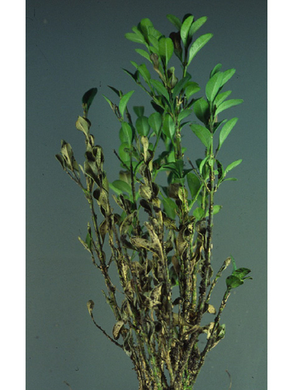
Triebsterben
am
Buchsbaum
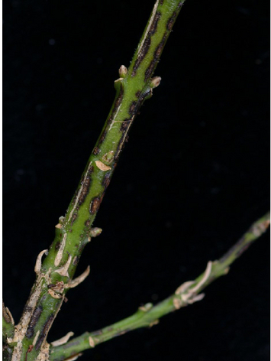
Typische
schwarz
verfärbte
Läsionen
am
Trieb
Symptoms
on
the
boxwood
are
striking.
Initially,
on
the
younger
leaves
are
found
small
brownish
spots,
which
have
a
dark
edge.
As
the
disease
progresses,
the
leaves
turn
brown,
leaf
drop
occurs,
and
entire
shoots
die.
With
sufficient
moisture,
a
white
spore
coating
forms
on
the
undersides
of
the
leaves.
Very
dark,
almost
black,
streak-like
lesions
form
on
the
shoots.

Host
plants
Only
species
of
the
genus
Buxus
are
attacked.
Studies
have
shown
that
there
are
differences
in
susceptibility
among
different
species
and
varieties
of
boxwood.
For
example,
Buxus
sempervirens
'Suffruticosa',
'Rotundifolia',
'Handworthiensis'
and
'Raket'
are
considered
highly
susceptible,
while
Buxus
sempervirens
'Blauer
Heinz'
is
susceptible.
The
cultivars
'Arborescens',
'Elegantissima'
and
'Herrenhausen'
and
Buxus
micorphylla
'Faulkner'
are
considered
relatively
resistant.
Densely
planted
bed
borders
and
plants
cut
into
spheres
or
figures
are
particularly
at
risk,
as
leaf
wetness
can
be
retained
particularly
well
and
for
a
long
time
here.

Distribution
In
Europe,
Cylindrocladium
buxicola
has
been
detected
in
Belgium,
Germany,
France,
Ireland,
the
Netherlands,
and
the
United
Kingdom.
There
are
also
reports
of
the
occurrence
of
this
pathogen
from
New
Zealand.
In
recent
years,
the
fungus
has
become
increasingly
noticeable
in
Germany,
especially
in
northern
Germany.
In
the
meantime,
shoot
dieback
is
also
increasingly
occurring
in
Austria.
In
particular,
the
sometimes
high
humidity
between
June
and
August
and
the
warm
temperatures
are
likely
to
have
favored
the
spread
of
the
pathogen.

Propagation
and
transmission
For
successful
infection,
the
fungus
requires
a
leaf
wetting
period
of
at
least
five
hours.
After
germination
of
the
conidia,
it
penetrates
either
via
wounds
(pruning
measures,
injuries)
or
directly
into
the
healthy
plant
tissue.
Under
conditions
optimal
for
the
fungus,
the
first
leaf
spots
appear
after
about
a
week
and
leaf
drop
begins.
A
white
spore
lawn
is
found
on
the
undersides
of
the
leaves
under
high
humidity
conditions,
which
serves
to
further
spread
the
fungus
during
the
growing
season.
With
wind
and
water
splashes,
the
spores
are
further
spread
in
the
stand.
Overwintering
occurs
by
means
of
permanent
spores
(chlamydiospores)
which
can
survive
in
the
soil
on
dead
leaves
for
at
least
four
years.

Prevention
and
control
- Since
leaf
wetness
is
an
important
prerequisite
for
infection,
avoiding
it
is
one
way
to
reduce
the
probability
of
infestation.
Unfortunately,
this
is
difficult
to
implement
in
the
field.
However,
when
planting,
wind-open,
sunny
locations
should
be
preferred
to
promote
drying
of
the
plants.
Supplemental
irrigation
should
be
applied
directly
to
the
root
and
not
through
the
foliage.
- There
are
differences
in
susceptibility
among
the
various
cultivars.
The
widely
used
cultivars
'Suffruticosa'
and
'Blauer
Heinz'
are
considered
highly
susceptible,
while
'Arborescens'
is
less
susceptible.
Multi-year
variety
trials
show
that
the
Buxus
microphylla
cultivars'Herrenhausen'
and
'Faulkner'
are
the
least
susceptible
to
C.
buxicola
infestation.
However,
infestation
cannot
be
completely
avoided
by
cultivar
selection
at
this
time.
- Diseased
plants
should
be
removed
together
with
the
fallen
foliage
and
destroyed
(in
residual
waste,
by
professional
composting
(hot
rotting),
by
burning
or
deep
burial).
The
top
layer
of
soil
should
also
be
removed
in
the
process,
as
the
pathogen
survives
in
the
soil
for
many
years.
- Equipment
and
tools
used,
as
well
as
shoes
and
hands,
should
be
thoroughly
cleaned
and,
if
possible,
disinfected
after
work
on
diseased
plants
has
been
completed,
before
further
plantings
are
worked
on.

Specialized
information
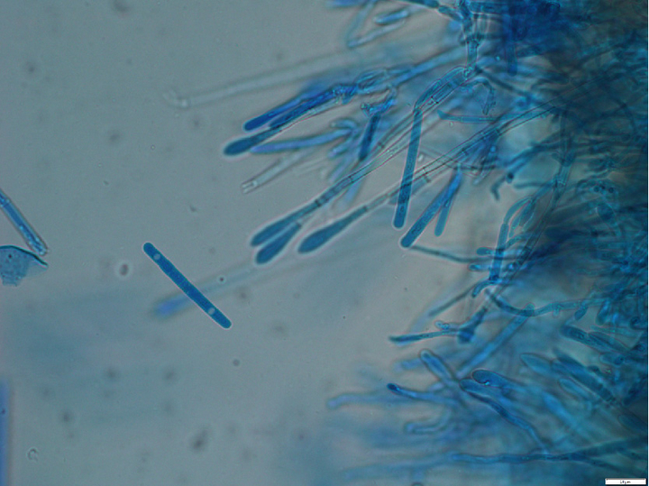
Konidien
von
Cylindrocladium
buxicola
und
sterile
Fortsätze
der
Konidienträger
Fungi
from
the
genus
Cylindrocladium
are
better
known
as
root
rot
pathogens
in
ornamental
plants
but
also
in
numerous
forest
plants.
Cylindrocladium
buxicola
,
however,
infects
the
plants
via
the
leaves.
For
this
purpose,
the
fungus
itself
can
overcome
the
healthy
cuticle,
i.e.
injuries
are
not
necessary
for
a
successful
infection.
In
terms
of
humidity,
five
to
seven
hours
of
leaf
wetness
are
sufficient
and
the
spores
germinate
after
only
three
hours
of
high
humidity.
It
is
also
not
very
demanding
in
terms
of
temperature;
the
fungus
starts
to
grow
at
5
°C
already.
Its
temperature
optimum
is
25
°C.
Cylindrocladium
buxicola
does
not
tolerate
high
heat.
Above
30
°C
it
stops
growing
and
at
temperatures
above
33
°C
the
fungus
is
killed.
However,
its
chlamydospores
can
survive
for
at
least
four
years
even
in
dead
plant
material.
The
conidia
have
the
shape
typical
of
fungi
of
the
genus
Cylindrocladium
.
They
are
simply
septate,
rounded
at
both
ends
and
cylindrical.
Their
length
is
42
-
68
µm
and
their
width
is
about
4
-
6
µm.
The
sterile
processes
of
the
conidia
carriers
are
95-155
μm
long.
On
culture
medium
(PDA,
MA)
its
growth
is
about
2
cm
per
week.
Initially,
colonies
are
brown
in
color
in
the
center
and
become
progressively
lighter
toward
the
edges.
Conidia
formation
begins
after
about
seven
days.
Literature
Brand,
T.,
2005.
occurrence
of
Cyclindrocladium
buxicola
B.
Henricot
on
boxwood
in
northwest
Germany,
Nachrichtenbl.
Deut.
Pflanzenschutzd.
57(12),
237-240.
ISSN
0027-7479.
Henricot,
B.,
Culham,
A.,
2002.
a
new
species
of
Cylindrocladium
affecting
Buxus
Mycologia
94(6),
993.
EPPO,
2005.
cylindrocladium
buxicola
-
A
new
leaf
and
twig
blight
of
Buxus.
EPPO
Alert
List,
EPPO
RS
2004/123.

Links
Information
from
EPPO
about
shoot
dieback
on
boxwoods

Services
Plant
Health
Services

