|  |  |
| --- | --- |
| Logo AGES | |
| Beet cyst eelworm | |
|  |  |
| 09.05.2025 16:50 Uhr | |

**Beet
cyst
eelworm**

**Heterodera
schachtii**

Last
change:
23.10.2024

**Profile**

Beet
cyst
nematodes
are
economically
the
most
important
plant-parasitic
nematodes
in
sugar
beet
cultivation.
They
have
a
broad
host
plant
spectrum
and
can
reproduce
on
over
200
plant
species,
including
many
cultivated
species,
especially
in
the
cruciferous
and
goosefoot
plant
families.
Beet
cyst
nematodes
are
typical
crop
pests
and
can
cause
yield
losses
of
between
5
and
50%.

**Appearance**

Beet
cyst
nematodes
are
microscopic
nematodes
that
live
in
the
soil
and
parasitize
roots.
Females
of
beet
cyst
nematodes
can
be
identified
as
pin-sized
white
"dots"
(immature
cysts)
on
the
roots
of
infested
host
plants.
The
second
larval
stage
larvae
are
colorless
and
translucent
and
about
0.5
mm
long.
They
possess
a
strong
mouth
spine.
The
cysts
average
0.6
to
0.8
mm
in
size
and
are
lemon
shaped.
Immature
cysts
that
are
still
on
the
roots
of
the
plant
are
white
while
mature
cysts
that
fall
off
the
roots
and
remain
in
the
soil
are
brown
in
color.

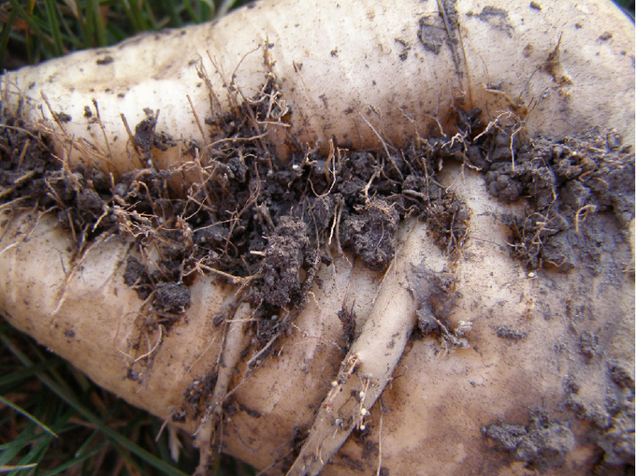

Zuckerrübe
mit
weißen
und
braunen
Zysten
an
den
Wurzeln

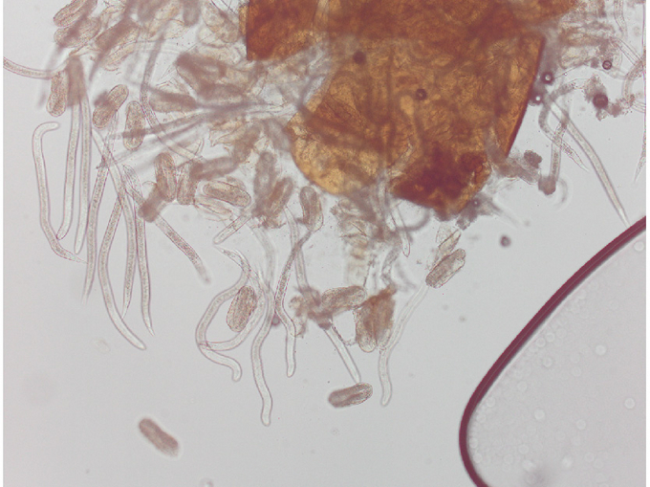

Eier
und
Larven
schlüpfen
aus
einer
Zyste

**Biology**

Beet
cyst
nematodes
are
classified
among
the
nematodes
(Nematoda)
in
the
family
Heteroderidae.

Beet
cyst
nematodes
live
in
the
soil
and
can
survive
for
years
in
their
permanent
form,
the
brown
cysts
filled
with
eggs
or
larvae,
even
without
host
plants.
Therefore,
they
may
well
be
detected
in
fields
where
sugar
beet
has
not
been
grown
for
many
years.
Mature
cysts
are
filled
with
up
to
500
eggs
and
larvae,
which
remain
dormant
until
external
influences
(mainly
climatic)
activate
them
to
hatch
from
the
cysts.
The
second
larval
stage
larvae
migrate
to
young,
growing
roots,
penetrate
plant
tissue,
using
the
powerful
mouth
spine,
and
develop
into
males
and
females
in
the
root
through
the
third
and
fourth
larval
stages.
While
the
males
are
worm-shaped
and
mobile,
the
females
are
lemon-shaped
and
attached
to
the
roots,
where
they
continue
their
sucking
activity.
After
fertilization
and
maturation
of
the
eggs,
the
females
die
and
remain
viable
as
a
cyst
in
the
soil
for
years.
Under
suitable
conditions
(weather
and
temperature),
beet
cyst
nematodes
develop
several
generations
per
year.
To
complete
a
generation,
beet
cyst
nematodes
require
a
heat
sum
of
465°C.
This
results
from
the
sum
of
the
daily
average
soil
temperatures
at
a
soil
depth
of
ten
to
20
cm
and
the
values
above
the
base
temperature
of
8
°C.

**Damage
symptoms**

Affected
plants
wilt,
decline
and
show
growth
retardation.
This
type
of
damage
usually
occurs
in
nests
in
the
stand
(around
June
in
warm
weather).
Infested
plants
wilt
more
than
non-infested
plants
during
dry
periods
in
the
sunshine;
they
recover
during
the
night.
The
beet
body
remains
small
and
branches
out,
forms
more
lateral
roots
and
a
so-called
root
beard
is
formed
(beardiness
of
the
beet).
Due
to
the
increased
lateral
root
formation,
there
is
an
increase
in
the
soil
attachment
to
the
beet.

Lemon
shaped
cysts
are
found
on
the
lateral
roots.

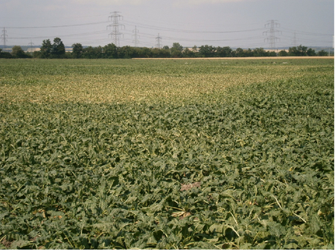

Nesterweiser
Befall
im
Bestand

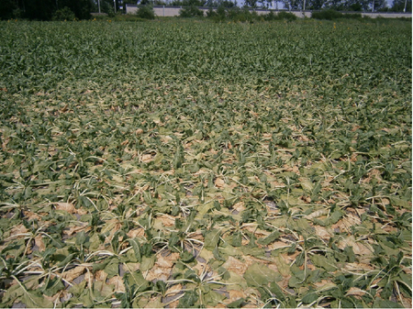

Welkesymptome
einer
anfälligen
Zuckerrübensorte

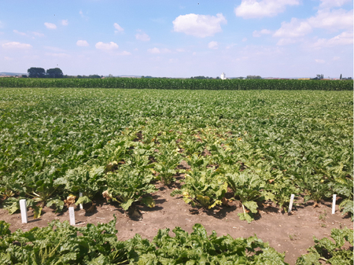

Welke-
und
Vergilbungssymptome
bei
einer
anfälligen
Zuckerrübensorte
(Bildmitte),
daneben
keine
Symptome
bei
nematodentoleranten
Zuckerrübensorten

**Host
plants**

The
host
plants
of
beet
cyst
nematodes
are
mainly
cruciferous
plants
(Brassicaceae)
and
goosefoot
plants
(Chenopodiaceae)
such
as.
Sugar
beet,
fodder
beet,
rapeseed,
turnip,
all
types
of
cabbage,
kohlrabi,
radish,
radish,
spinach,
chard,
oil
radish,
mustard,
as
well
as
numerous
weeds
such
as
species
of
melilot,
goosefoot
species,
field
mustard,
shepherd's
purse,
chickweed,
etc.

**Distribution**

Beet
cyst
nematodes
are
found
in
almost
all
intensive
beet-growing
areas
in
Europe,
and
globally
they
are
also
found
in
North
America,
Asia
and
Australia.
In
Austria,
beet
cyst
nematodes
are
present
in
some
beet
growing
areas.

**Propagation
and
transmission**

Larvae
of
beet
cyst
nematodes
have
low
active
dispersal
(migration)
in
the
soil.
Spread
from
one
infested
area
to
another
area
occurs
passively
through
the
carryover
of
larvae
and
cysts
by
soil
that
may
adhere
to
harvesting
equipment,
tillage
equipment,
tractor
tires,
or
transport
vehicles.
Consideration
should
be
given
to
the
spread
of
cysts
by
wind
and
water
erosion
and
by
shared
harvesting
equipment.

**Economic
importance**

Beet
cyst
nematodes
are
economically
the
most
important
nematodes
in
sugarbeet
cultivation.
They
can
cause
between
five
and
50%
crop
loss.
Yield
losses
are
also
influenced
by
the
time
of
sowing,
the
weather
and
the
initial
infestation.

**Prevention
and
control**

* Timely
  detection
  of
  infestation
  by
  soil
  testing
  for
  beet
  cyst
  nematodes
  prior
  to
  planned
  cultivation.
* Pay
  attention
  to
  farm
  hygiene:
  In
  the
  event
  of
  nematode
  infestation
  on
  the
  farm,
  cleaning
  of
  cultivation
  equipment,
  footwear
  and
  vehicles
  is
  of
  great
  importance
  to
  prevent
  the
  cysts
  from
  spreading
  with
  soil
  to
  other
  areas.
  Waste
  soil
  from
  grading
  should
  never
  be
  spread
  on
  cropland
  or
  on
  the
  manure
  pile
  (risk
  of
  nematode
  spread
  with
  manure
  application).
* Four-year
  crop
  rotation
  is
  essential.
  Cultivation
  of
  intercrops
  such
  as
  corn,
  rye,
  alfalfa,
  chicory,
  flax,
  and
  onion
  induces
  nematode
  larvae
  to
  hatch
  but
  prevents
  their
  further
  development.
  Neutral
  crops,
  such
  as
  cereals,
  potato,
  poppy,
  pea,
  clover,
  sunflower
  and
  hemp,
  are
  also
  recommended
  in
  crop
  rotation
* Cultivation
  of
  nematode-resistant
  catch
  crops,
  e.g.,
  resistant
  oil
  radish
  or
  mustard
  varieties
  nematode-resistant
  sugar
  beet
  varieties
  to
  reduce
  and
  mitigate
  a
  nematode
  population.
* Cultivation
  of
  a
  tolerant
  sugarbeet
  variety
  to
  safeguard
  yields
  when
  infestation
  with
  beet
  cyst
  nematodes
  has
  been
  detected
  on
  an
  area.
  Cultivation
  of
  tolerant
  sugarbeet
  varieties
  reduces
  the
  risk
  of
  yield
  loss;
  however,
  tolerant
  sugarbeet
  varieties
  may
  contribute
  to
  an
  increase
  in
  beet
  cyst
  nematodes.

**Specialized
information**

[Detection
of
beet
cyst
nematodes](en/plant/plant-health/plant-health-information#c4953)
on
an
area
can
be
determined
by
soil
testing
according
to
a
sampling
plan.

**Services**

[Plant
Health
Services](en/plant/plant-health/plant-health-information)

[Detection
of
cyst-forming
nematodes](en/plant/plant-health/plant-health-information#c4954)

[Nematode
testing](en/plant/plant-health/plant-health-information#c4953)