|  |  |
| --- | --- |
| Logo AGES | |
| Barley yellow dwarf | |
|  |  |
| 09.05.2025 21:31 Uhr | |

**Barley
yellow
dwarf**

**Barley
yellow
dwarf
virus**

Last
change:
02.05.2024

**Profile**

Cereal
yellows
blight
is
a
disease
caused
by
the
yellows
blight
viruses.
These
are
some
of
the
most
widespread
plant
viruses.
Infection
occurs
via
aphids
infected
with
the
virus.
Symptoms
of
the
virus
infection
include
small
growth
and
yellow-orange
discoloration
of
the
leaves.

**Biology**

Cereal
yellow
dwarfing
is
caused
by
the
yellow
dwarfing
viruses.
This
is
a
collective
term
for
Barley
yellow
dwarf
virus
(BYDV)
and
Cereal
yellow
dwarf
virus
(CYDV).
These
are
further
subdivided
into
different
serotypes,
each
of
which
is
mainly
transmitted
by
one
aphid
species.
The
greatest
damage
occurs
in
early-planted
winter
barley
(which
is
why
it
is
often
referred
to
only
as
barley
yellow
dwarf),
but
all
other
cereals,
corn,
and
many
grass
species,
especially
pasture
grasses,
can
also
be
infected.
Rye
and
triticale
are
the
most
resistant.

**Damage
symptoms**

Dwarfism
and
general
changes
in
the
appearance
of
the
plants
combined
with
discoloured
and
partially
deformed
leaves
are
conspicuous.
Deaf
ears
also
develop.
The
first
symptoms
can
already
be
seen
in
autumn
in
early-grown
cereals.
In
winter
barley,
the
dwarfing
is
more
pronounced
than
in
winter
wheat.
If
barley
is
severely
stalked,
there
is
increased
tillering
and
the
result
is
a
grass-like
appearance.
Streaky
lightening
between
the
leaf
veins
and
on
the
leaf
edges
is
also
typical.
Oats
and
wheat,
on
the
other
hand,
hardly
tiller
at
all
and
the
flag
leaves
are
reddish-purple
in
colour.
Yellow
dwarfing
usually
occurs
in
nests,
but
whole
fields
can
be
infected
if
the
infestation
is
severe.

[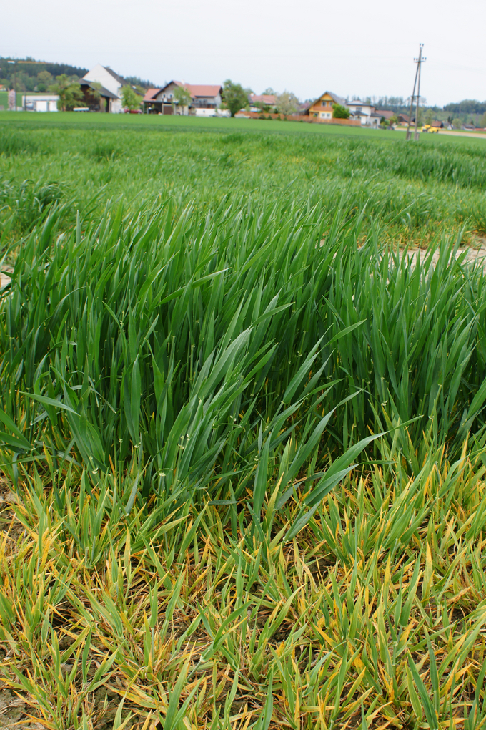](download/sdl-eyJ0eXAiOiJKV1QiLCJhbGciOiJIUzI1NiJ9.eyJpYXQiOjE2MDk0NTkyMDAsImV4cCI6NDA3MDkwODgwMCwidXNlciI6MCwiZ3JvdXBzIjpbMCwtMV0sImZpbGUiOiJmaWxlYWRtaW4vX3Byb2Nlc3NlZF8vZi8yL2NzbV9HZWxidmVyendlcmd1bmdfMV80ODA3N2MyZGVhLmpwZyIsInBhZ2UiOjEzMDZ9.JTNFbJh25E7auo7cgAMHWUGpI13M732fJgID1_6ZUZw/csm_Gelbverzwergung_1_48077c2dea.jpg)

When
germinating
later
in
autumn,
this
winter
barley
variety
was
partially
uninfected.

[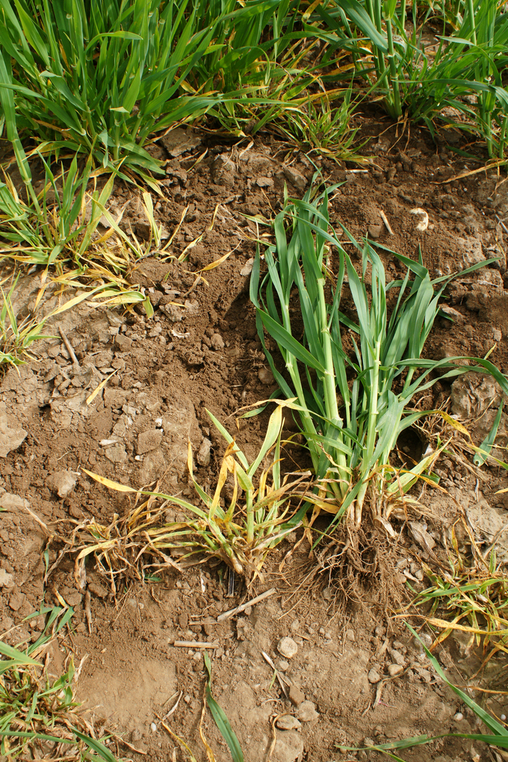](download/sdl-eyJ0eXAiOiJKV1QiLCJhbGciOiJIUzI1NiJ9.eyJpYXQiOjE2MDk0NTkyMDAsImV4cCI6NDA3MDkwODgwMCwidXNlciI6MCwiZ3JvdXBzIjpbMCwtMV0sImZpbGUiOiJmaWxlYWRtaW4vX3Byb2Nlc3NlZF8vOS9kL2NzbV9HZWxidmVyendlcmd1bmdfNF82NzRlOGRlODk1LmpwZyIsInBhZ2UiOjEzMDZ9.nBjGXqKaYJG-tygk8ZHOhfdU0YU6VEpYd136Uy12_6E/csm_Gelbverzwergung_4_674e8de895.jpg)

The
two
barley
plants
on
the
left
are
severely
damaged
by
the
BYD
virus.
The
plant
on
the
right
is
developing
normally
(early
April).

[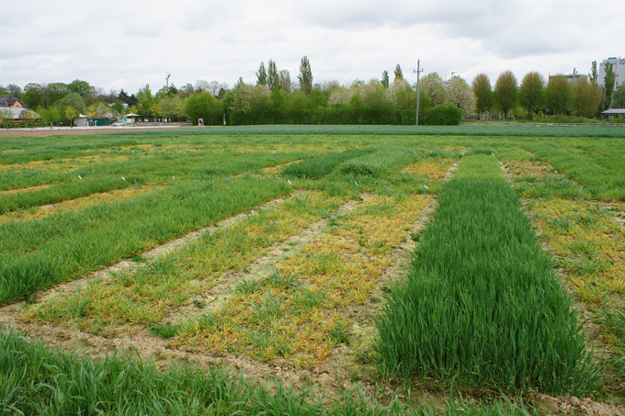](download/sdl-eyJ0eXAiOiJKV1QiLCJhbGciOiJIUzI1NiJ9.eyJpYXQiOjE2MDk0NTkyMDAsImV4cCI6NDA3MDkwODgwMCwidXNlciI6MCwiZ3JvdXBzIjpbMCwtMV0sImZpbGUiOiJmaWxlYWRtaW4vX3Byb2Nlc3NlZF8vYi8yL2NzbV9HZWxidmVyendlcmd1bmdfMl85NGIzNjkwZjAzLmpwZyIsInBhZ2UiOjEzMDZ9.ZO1nw2pi6LeKMMbs9ISSKVf3IAfp1l5DTU62_vnz_Rk/csm_Gelbverzwergung_2_94b3690f03.jpg)

Varietal
differences
in
winter
barley
with
simultaneous
cultivation.

[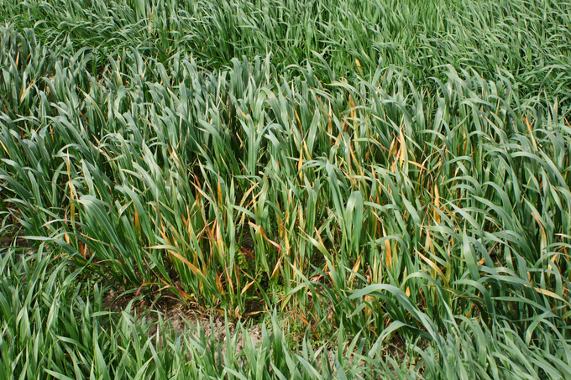](download/sdl-eyJ0eXAiOiJKV1QiLCJhbGciOiJIUzI1NiJ9.eyJpYXQiOjE2MDk0NTkyMDAsImV4cCI6NDA3MDkwODgwMCwidXNlciI6MCwiZ3JvdXBzIjpbMCwtMV0sImZpbGUiOiJmaWxlYWRtaW4vX3Byb2Nlc3NlZF8vZC80L2NzbV9HZWxidmVyendlcmd1bmdfNV85YjE2Yzg0ODEyLmpwZyIsInBhZ2UiOjEzMDZ9.wNUVf69DRLKvAK8p9QOk6NcovHnFYuBZScehddrT6HU/csm_Gelbverzwergung_5_9b16c84812.jpg)

With
lighter
infestations,
the
damage
occurs
in
nests
(here
in
the
picture
winter
oats).

[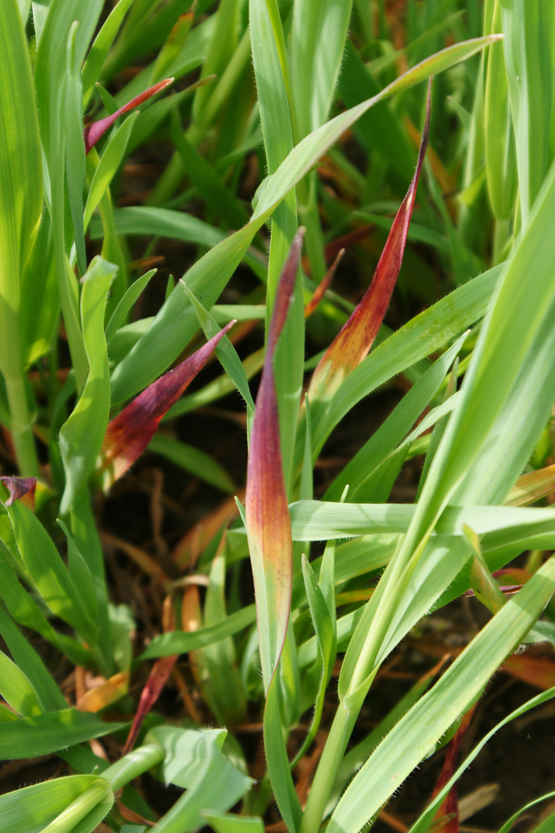](download/sdl-eyJ0eXAiOiJKV1QiLCJhbGciOiJIUzI1NiJ9.eyJpYXQiOjE2MDk0NTkyMDAsImV4cCI6NDA3MDkwODgwMCwidXNlciI6MCwiZ3JvdXBzIjpbMCwtMV0sImZpbGUiOiJmaWxlYWRtaW4vX3Byb2Nlc3NlZF8vMC8zL2NzbV9HZWxidmVyendlcmd1bmdfM18xZDQxYTM5MGJjLmpwZyIsInBhZ2UiOjEzMDZ9.rZvdd-z2q8tfVRVHNa9zbcoDzbob4-0qxxLrGQQTky8/csm_Gelbverzwergung_3_1d41a390bc.jpg)

Winter
oats
react
to
the
virus
infestation
with
reddish
discolouration

**Host
plants**

The
virus
affects
all
cereals,
corn
and
many
grass
species,
especially
ryegrasses.

**Distribution**

The
yellow
warts
viruses
are
distributed
worldwide.

**Propagation
and
transmission**

Barley
yellow
dwarf
virus
is
transmitted
by
[aphids](en/plant/plant-health/pests-from-a-to-z/aphids).
A
total
of
more
than
24
aphid
species
are
known
to
be
possible
carriers,
including
the
pale
cereal
aphid*(Macrosiphum
dirhodum*).
According
to
literature,
the
aphids
need
one
to
twelve
hours
of
sucking
activity
to
take
up
the
virus
from
infested
plants.
After
one
to
two
days
of
residence
time
of
the
viruses
in
the
body
of
the
aphids,
the
virus
can
be
transmitted
by
these
animals
throughout
their
life.
Virus
transmission
occurs
after
several
hours
of
sucking
on
plants.

Incoming
aphids
infect
the
cereal
plants
and
the
offspring
of
these
aphids
can
spread
the
disease
in
the
crop.
The
longer
the
aphids
have
time
to
reproduce,
the
larger
the
infested
areas
become.
Aphid
immigration
and
reproduction
is
encouraged
by
mild
and
dry
weather
in
the
fall.
Significant
sources
of
infection
in
the
fall
are
infected
volunteer
cereals,
corn,
but
also
grasses
on
grassland,
field
margins
and
weeds.

**Economic
importance**

In
the
past,
yellow
wilt
of
cereals
was
observed
annually
on
winter
cereals,
especially
in
the
Pannonian
region.
In
the
meantime,
large
losses
due
to
this
disease
can
be
expected
in
all
cereal-growing
regions
and
for
all
cereal
types
if
mild
weather
persists
in
the
fall.
Heavily
infested
winter
crops
usually
have
to
be
turned
over
in
spring.

**Prevention
and
control**

* Avoidance
  of
  extreme
  early
  sowing
  of
  winter
  cereals
  is
  the
  best
  protection
  against
  fall
  infections
* Careful
  control
  of
  volunteer
  cereals
  before
  the
  emergence
  of
  winter
  crops
* Maintenance
  of
  field
  and
  roadsides
* Reduction
  of
  infestation
  through
  gap-free
  and
  rapid
  emergence
  of
  winter
  tillage
  (aphids
  prefer
  to
  fly
  into
  gaps)
* Early
  cultivation
  of
  summer
  tillage
  (in
  contrast
  to
  winter
  tillage)
* Control
  of
  aphids
  by
  insecticidal
  spray
  treatments
  in
  the
  stand
  (see
  [list
  of
  plant
  protection
  products
  approved
  in
  Austria](https://www.baes.gv.at/zulassung/pflanzenschutzmittel/pflanzenschutzmittelregister/))

**Specialized
information**

Since
2019,
[cereal
virus
monitoring](https://warndienst.lko.at/getreidevirosen+2500++1075648+6635)
has
been
carried
out
by
the
chambers
of
agriculture
in
cooperation
with
us.
Interested
farmers
can
get
an
overview
of
the
virus
situation
in
their
region
and,
if
necessary,
postpone
the
cultivation
date.

**Services**

[Plant
Health
Services](en/plant/plant-health/plant-health-information)