Borrelia

07.05.2024 06:13 Uhr

Borrelia

Borrelia
burgdorferi
sensu
lato
Last
change:
10.10.2023

Profile
Lyme
disease,
borreliosis
or
Lyme
disease
is
an
infectious
disease
caused
by
bacteria
(borrelia).
It
is
transmitted
primarily
by
ticks.
Lyme
disease
is
the
most
common
tick-borne
infectious
disease
in
the
Northern
Hemisphere.

Occurrence
Lyme
borreliosis
is
a
worldwide
disease.
The
main
areas
of
distribution
are
North
America,
Europe,
Asia
and
North
Africa.

Pathogen
reservoir
mice
and
birds,
but
also
other
animals
such
as
reptiles,
hedgehogs,
foxes
or
rabbits.
Over
30
percent
of
the
common
wood
tick;
the
most
common
tick
species
in
Central
and
Northern
Europe,
are
infected
with
Borrelia.

Infection
route
Transmission
occurs
via
the
bite
of
infected
ticks.
The
Borrelia
bacteria
are
transmitted
to
humans
after
a
few
hours
during
the
biting
and
sucking
act
of
the
tick.
Not
all
ticks
are
infected
and
not
every
tick
bite
leads
to
Lyme
disease.
The
risk
of
infection
is
about
5%.
There
is
no
transmission
from
human
to
human.

Incubation
period
The
incubation
period
of
early
Lyme
disease,
which
is
the
most
common
form,
varies
from
a
few
days
to
several
weeks.

Symptomatology
A
typical
ring-shaped,
reddish
rash
called
erythema
migrans
or
wandering
redness
occurs
in
about
85%
of
cases.
Headache,
fever,
fatigue
or
joint
pain
may
also
occur.
With
proper
and
prompt
treatment,
symptoms
resolve
quickly.
Another
form
of
Lyme
disease
affects
the
nervous
system:
a
few
weeks
after
infection,
meningitis
and
facial
nerve
paralysis
may
occur,
especially
in
children,
and
painful
nerve
root
inflammation
and
paralysis
in
adults.
Other
rare
forms
include
joint
inflammation
and
typical
skin
lesions
on
the
extensor
sides
of
the
extremities.
In
most
forms,
timely
antibiotic
treatment
leads
to
sustained
improvement;
untreated,
Lyme
disease
can
lead
to
long-lasting
symptoms.

Therapy
Lyme
disease
is
treated
with
antibiotics.
The
duration
of
treatment
depends
on
the
stage
of
the
disease.
Early
forms
of
Lyme
disease
are
treated
over
a
period
of
10
to
14
days.
Late
forms
are
treated
over
four
weeks.

Prevention
There
is
currently
no
vaccination
against
Lyme
disease.
The
most
important
preventive
measure
is
protection
against
tick
bites:
well-fitting,
closed
clothing
and
avoidance
of
undergrowth,
tall
grass,
dense
bushes
in
gardens
or
near
forests.

Situation
in
Austria
In
Austria,
Lyme
borreliosis
is
a
frequently
diagnosed
disease,
but
not
reportable.
It
is
estimated
that
25,000
to
70,000
people
become
ill
each
year.
Most
cases
are
observed
in
spring
and
summer,
when
people
spend
more
time
outdoors
and
are
bitten
more
often
by
ticks.

Specialized
information
Lyme
disease,
borreliosis
or
Lyme
disease
is
an
infectious
disease
caused
by
bacteria
from
the
Borrelia
burgdorferi
sensu
lato
complex.
This
term
includes
those
Borrelia
species
that
cause
most
infections
in
Europe:
B.
afzelii,
B.
garinii,
B.
bavariensis,
and
B.
burgdorferi
sensu
stricto.
The
common
wood
tick(Ixodes
ricinus)
is
the
most
common
vector
of
Borrelia
in
Europe.
The
development
of
Ixodes
ricinus
includes
three
stages:
larva,
nymph,
and
adult
(adult)
tick.
Small
rodents
or
birds
are
the
most
common
hosts
for
larvae,
and
larger
rodents
or
medium-sized
mammals,
such
as
cats
or
dogs,
for
nymphs.
Larger
hosts,
such
as
deer
and
deer,
are
important
blood
hosts
for
adult
ticks,
but
are
not
reservoirs
of
Borrelia.
Ticks
pick
up
borrelia
from
one
host
animal
during
a
blood
meal
and
pass
it
on
to
the
next
host.

Symptoms

Erythema
migrans
(wandering
redness)
Erythema
migrans
(wandering
redness)
is
the
most
common
disease
symptom
of
Lyme
borreliosis
(>
80
percent
of
all
cases).
Erythema
migrans
develops
at
the
earliest
3-6
days
up
to
several
weeks
after
the
tick
bite
around
the
tick
bite
site
as
an
enlarging
red
or
blue-red
spot
with
or
without
later
central
lightening.
The
outer
edge
is
clearly
separated,
often
more
intensely
colored
and
not
noticeably
raised.
If
the
diameter
is
at
least
five
centimeters,
the
diagnosis
is
made
clinically
by
an
experienced
physician.
If
the
diameter
is
smaller,
the
diagnosis
requires
a
confirmed
tick
bite,
a
delay
of
at
least
two
days
in
the
appearance
of
the
erythema
after
the
tick
bite,
and
increasing
erythema
at
the
tick
bite
site.
Accompanying
symptoms
such
as
local
itching/burning,
fatigue,
headache,
joint
pain
can
occur
with
erythema
migrans
with
a
frequency
of
40%.
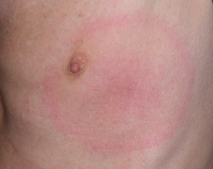
Erythema
migrans
on
the
left
breast
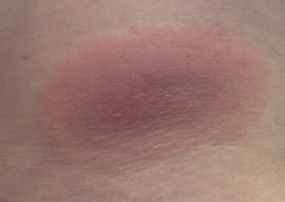
Erythema
migrans
in
the
lumbar
region
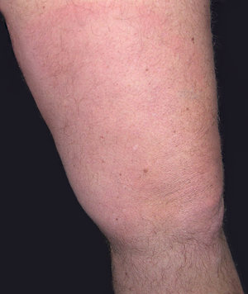
Erythema
migrans
on
the
left
thigh

Borrelia
lymphocytoma
Borrelia
lymphocytoma
is
a
painless,
blue-red
nodule
or
spot,
usually
on
the
earlobe,
auricle
margin,
nipple,
or
scrotum.
It
is
more
common
in
children
(especially
on
the
ear)
than
in
adults.
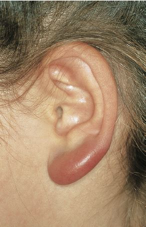
Borrelia
lymphocytoma
on
the
left
ear

Acrodermatitis
chronica
atrophicans
(ACA)
Acrodermatitis
chronica
atrophicans
(ACA)
is
a
chronic
progressive
skin
disease
caused
by
Lyme
borrelia
that
does
not
heal
spontaneously.
ACA
begins
with
a
red
or
blue-red
change
in
the
skin,
usually
on
the
extensor
sides
of
the
arms
or
legs,
which
may
persist
for
a
long
time.
Later,
there
is
a
disappearance
of
all
skin
layers
(skin
atrophy),
the
skin
becomes
thin
"like
cigarette
paper"
and
easily
vulnerable.
Neuropathies
(damage
to
nerves)
may
occur
in
the
affected
skin
area.
With
long-standing
ACA,
the
joints
in
the
affected
skin
area
are
also
affected.
Skin
thickening
and
slowly
growing,
painless,
fibroid
nodules
(benign
tumors)
may
develop
over
bony
prominences.
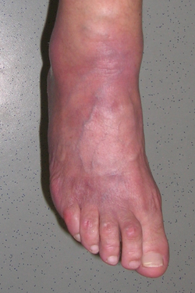
Acrodermatitis
chronica
atrophicans
in
a
70-year-old
female
patient.

Lyme-Neuroborreliose
Lyme
neuroborreliosis
occurs
in
adults
mainly
as
meningitis
and
as
very
painful
nerve
root
inflammation
(Garin-Bujadoux-Bannwarth
syndrome).
Rarely,
brain
inflammation
(encephalitis),
spinal
cord
inflammation
(myelitis),
and
very
rarely
inflammation
of
the
brain
vessels
(cerebral
vasculitis)
are
observed.
In
children,
Lyme
neuroborreliosis
mainly
manifests
as
facial
paralysis
or
mild
meningitis.

Lyme-Arthritis
Lyme
arthritis
is
characterized
by
recurrent
attacks
or
persistent,
objective
joint
swelling
in
one
major
joint
or
in
a
few
major
joints.
Almost
always,
the
knee
joint
is
affected.
Exclusion
of
other
causes
is
necessary.

Lyme
carditis
Lyme
carditis
occurs
rarely
and
is
characterized
by
conduction
disorders
and
cardiac
arrhythmia;
occasionally,
myocarditis
and
inflammation
of
all
layers
of
the
heart
wall
(pancarditis)
have
been
observed.
Exclusion
of
other
causes
is
necessary.

Eye
inflammation
Eye
inflammations
caused
by
pathogens
of
Lyme
borreliosis
are
observed
very
rarely.
They
can
affect
the
conjunctiva
(conjunctivitis),
iris
(uveitis),
sclera
(episcleritis)
and
cornea
(keratitis),
as
well
as
the
optic
nerve
head
(papillitis).

Therapy
Lyme
disease
is
treated
with
antibiotics.
Various
treatment
options
are
available
for
this.
The
duration
of
treatment
depends
on
the
stage
of
the
disease.
Early
forms
of
Lyme
disease
are
usually
treated
with
oral
or
intravenous
antibiotics
over
a
period
of
10
to
14
days.
Late
forms
are
treated
over
four
weeks.
Most
patients
respond
well
to
antibiotic
therapy
and
show
improvement
in
their
symptoms.
This
is
especially
true
for
erythema
migrans
and
neuroborreliosis.
Timely
treatment
of
Lyme
borreliosis
is
important
to
avoid
possible
late
sequelae.

Diagnostic
The
diagnosis
of
erythema
migrans
can
be
made
by
the
physician
purely
clinically
-
i.e.
that
no
laboratory
examination
is
necessary.
All
other
forms
require
blood
testing
for
antibodies.
Serologic
tests
can
be
used
to
detect
antibodies
to
Borrelia
burgdorferi.
In
early
stages
of
the
disease,
these
tests
may
be
falsely
negative.
In
late
forms,
antibodies
are
always
present.
Interpretation
of
results
is
sometimes
difficult
because
even
healthy
individuals
may
have
antibodies
to
Borrelia.
That
is
why
the
correlation
with
symptoms
is
important
in
the
evaluation.
To
confirm
the
suspicion
of
Lyme
neuroborreliosis,
the
serum
and
cerebrospinal
fluid
must
be
taken
and
examined
with
special
methods.
Direct
pathogen
detection
of
Borrelia
(PCR,
culture)
is
not
suitable
for
routine
diagnosis
of
Lyme
borreliosis.

Contact

Institute
for
Medical
Microbiology
and
Hygiene
Vienna

Priv.-Doz.
Dr.
med
Mateusz
Markowicz
E-Mail:mateusz.markowicz@ages.at
Phone:+43
05
0555-37204
Address:
Währingerstraße
25a,
1090
Wien

